

Paisley Grammar School Biology Department

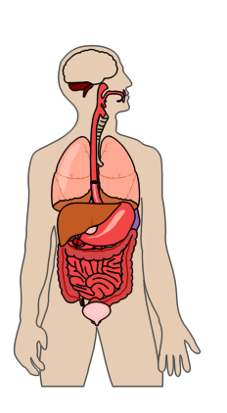
Standard Grade Biology
Animal Survival Homework Booklet

Name
Teacher
Homework | Date Due | Comment
1: Need for Food 1
2: Need for Food 2
3: Need for Food 3
4: Reproduction 1
5:Reproduction 2
6: Water and Waste
7: Responding to the Environment
Homework Exercise 1 The Need for Food 1
KU | PS

1. Dogs obtain energy from the food they eat. Some of this energy is used for growth.
State two other ways in which dogs use this energy. (2)

2. Four breakfast cereals were analysed for their nutritional content and the results are shown below. All the figures are for 100g of the cereal.

 | Energy (kJ) | Protein (g) | Fat  (g) | Carbohydrates (g) | Fibre (g)
Rice krispies | 1650 | 4 | 0.5 | 90 | 0.5
Nut flakes | 1700 | 8 | 4 | 82 | 1
Cocopops | 1600 | 5 | 2 | 87 | 1
Wheaties | 1400 | 11 | 1 | 67 | 13

(a) Which cereal supplies the most energy per 100 g (1PS)

- Which cereal contains the most carbohydrates per 100g
(1PS)

- For good health we are advised to eat less fat and carbohydrates, and to increase our fibre intake. Which of these cereals would we eat to help us do this? (1PS)

(d) What is the average amount of protein per 100g of cereal? (1PS)
3. The bar chart below shows some information on the components of mycoprotein compared with other foods that are traditional sources of animal protein. Mycoprotein is a food produced by a fungus.
50
KU | PS


10
20
30
40
Mass of component (g/100 g of food)
Protein

Fat
Cheese
Chicken
Sausage
Mycoprotein
Food

(a) Sausage has 9g of protein and 24g of fat per 100g.
Plot this data on the bar chart above. (2)

(b) (i) Which food has the highest protein content? (1)

(ii) Which food has the lowest fat content? (1)

(iii) Which foods have more fat than protein? (1)
(c) The mycoprotein has 12 g of protein and 3 g of fat per 100g. Calculate the protein to fat content in mycoprotein as a simple whole number ratio. (1)
KU | PS

Space for calculation

Protein : Fat

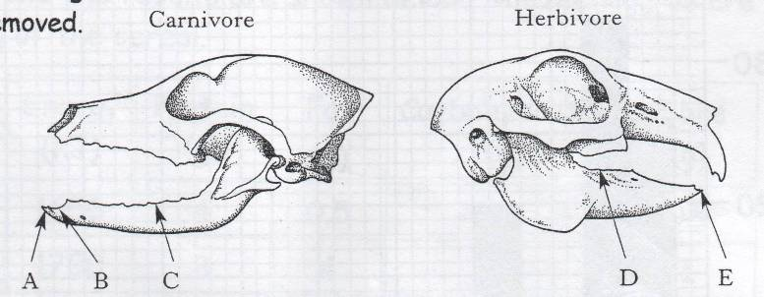
4. (a) The diagrams show the skulls of two mammals with the teeth removed.

Complete the table below by: (3)

(i) Selecting a letter from the diagrams above to indicate the position of each type of tooth.

(ii) Selecting a function from the list below:
- Piercing and holding
- Crushing and grinding
- Slicing and tearing

Tooth | Position | Function
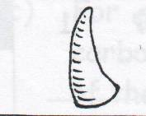
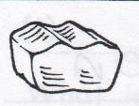
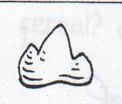
Homework Exercise 2 The Need for Food 2
KU | PS

1. The diagram below shows some of the parts of the human digestive system.
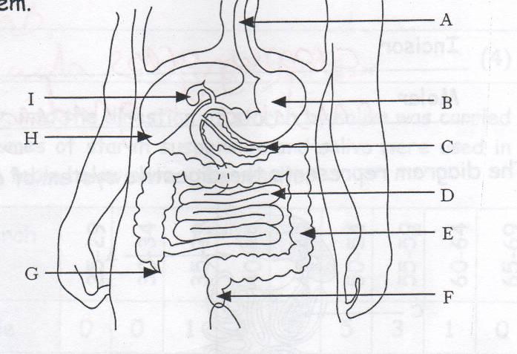

(a) (i) Complete the table by entering letters from the diagram to identify the named parts of the digestive system. (2)

Part of digestive system | Letter
Gall bladder
Rectum
Stomach
Small intestine

(ii) State one function of the large intestine. (1)

- Teeth are involved in the mechanical breakdown of food.
KU | PS

Describe the role of the following teeth in a herbivore. (2)
Incisor
Molar

2. The diagram represents the digestive system of a rabbit.
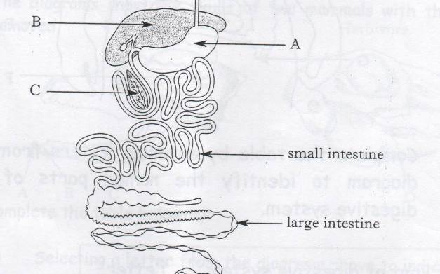
Small intestine
Large intestine

- Name the parts labelled with the following letters. (2)

A
B
C

- What feature of the small intestine, shown on the diagram, helps it to carry out its function efficiently?
(1)

- The mass of material which enters the large intestine after digestion is far greater than the mass of the faeces eliminated.
Name the substance which is removed from the material as it is passed along the large intestine. (1)
3. State the 4 main sites where digestive juices are produced.
KU | PS

(4)

4. An investigation into the digestion of starch by saliva was carried out. Equal volumes of starch suspension and saliva were used in each case. The table below shows the results.

Time to digest starch (mins) | 25-29 | 30-34 | 35-39 | 40-44 | 45-49 | 50-54 | 55-59 | 60-64 | 65-69
Number of people | 0 | 0 | 1 | 6 | 9 | 5 | 3 | 1 | 0

(a) Complete the bar chart below (3PS)

25-29
30-34
35-39
40-44
45-49
50-54
55-59
60-64
65-59
Time to digest starch (minutes)
(b) How many people took part in the investigation? 1PS
KU | PS

(c) How many people had saliva which digested the starch in 49 minutes or less? 1PS

- Name one variable, other than the volumes of starch and saliva, which should be kept constant to ensure a fair experiment. 1PS

Homework Exercise 3 The Need for Food 3
KU | PS

1. What is the function of the small intestine? (1)
2. The diagram below show villi in the small intestine of a mammal.
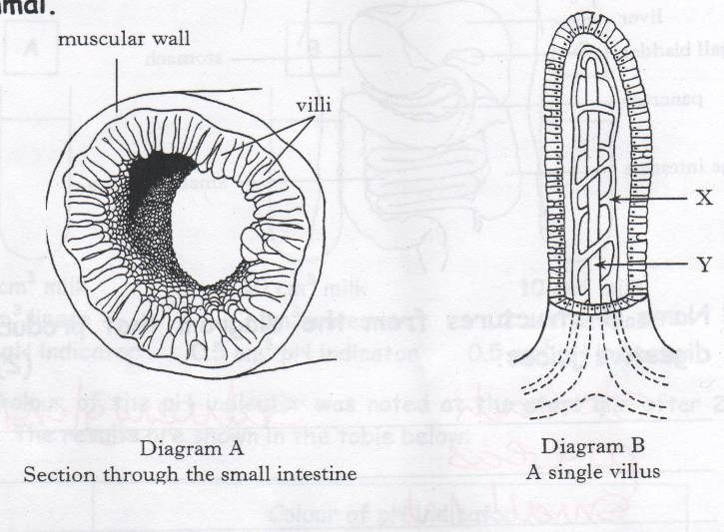
Diagram A
Section through the small intestine
Diagram B
A single villus
Muscular wall
Villi
(a) State how the arrangement of villi, shown in diagram A, increases the efficiency of absorption of digested foods. (1)

(b) Name the two structures, labeled X and Y on Diagram B, which transport digested food away from the intestine. (2)
X
Y

3. The following diagram shows the human digestive system.
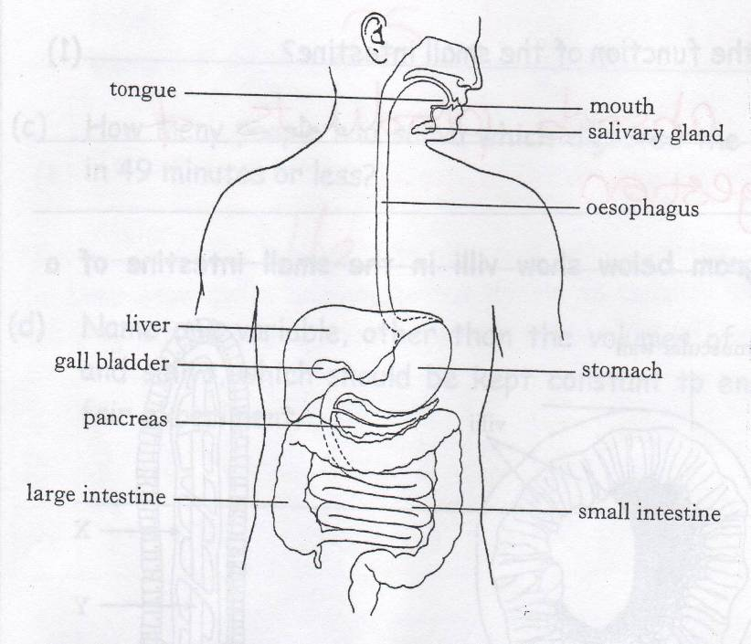
KU | PS

- Name 3 structures from the diagram that produce digestive juices. (2)
- Complete the following table (3)

Enzyme | Substrate | Product(s)
 |  | Maltose
 | Protein
Lipase |  | 1…………………………………..  2……………………………………

(c) What word describes the conditions in which enzymes work best? (1)
KU | PS

4. The activity of the enzymes lipase and catalase was investigated.
The three test tubes were set up as described:
10 cm³ milk
2 cm³ lipase
0.5 cm³ pH indicator
10 cm³ milk
2 cm³ water
0.5 cm³ pH indicator
10 cm³ milk
2 cm³ catalase
0.5 cm³ pH indicator
A
B
C
The colour of the pH indicator was noted at the start and after 20 mins. The results are shown in the table below:

 | Colour of pH indicator
Test tube | At start | After 20 minutes
A | Green | Orange
B | Green | Green
C | Green | Green

- In tube A, the pH indicator colour change was due to the production of fatty acids as the lipase reacted with the fat in the milk. Explain why there was no change in tube C.
(1)

- What term is used to describe tube B which contained water instead of an enzyme? (1)
KU | PS

- Name two variables, not already shown, which would have to be kept the same when this investigation was set up?
(2)

5. The villi which line the small intestine each contain a lacteal and blood capillaries.

Give a brief description of the function of each of these structures.

Lacteal
(1)
Blood capillaries
(1)

6. Explain how contraction of muscles in the stomach wall speeds up digestion. (1)

Homework Exercise 4 Reproduction 1
KU | PS

1. Sexual reproduction leads to variation in offspring. Male and female produce sex cells (gametes)

- Name the sex cells produced by a male. (1)

- Where are these sex cells made? (1)

- Name the female sex cells. (1)

- Where are these sex cells made? (1)

2. (a) The diagram shows a female sex cell about to be fertilised by a male sex cell.

nucleus
nucleus
Describe what would happen next, to complete fertilisation.
(1)

(b) Name the organ in which a human fetus completes its development. (1)
- A human sperm cell can swim at a rate of 2 mm per minute. How long would it take a sperm cell to swim 15 cm to reach an egg? (1)
KU | PS

______mins

3. There are two types of fertilisation: internal and external.

(a) What is meant by internal fertilisation? (1)

(b) Why is internal fertilisation important to land living animals? (1)

(c) What is meant by external fertilisation? (1)

- Why are there a lot more eggs and sperm released during external fertilisation compared with internal? (1)

7. Study the diagram below. It is of the male reproductive organ.
KU | PS

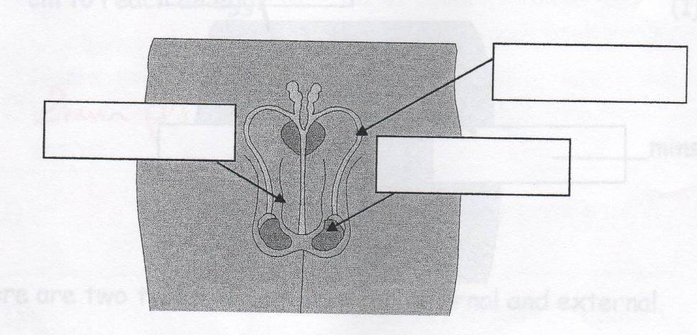
A
C

B
Identify parts A to C (3)
A =
B =
C =

Homework Exercise 5 Reproduction 2
KU | PS

1. (a) The grid below contains the names of structures in the reproduction system of mammals.

A | Uterus | B | Oviduct | C | Amniotic sac | D | Ovary

Use the letters from the grid to identify the structure

(i) where fertilisation occurs _________ (1)

(ii) which contains fluid to support the embryo _______ (1)

- The diagram below shows a sample being taken from the fluid which surrounds a fetus. This fluid contains cells from the fetus which are examined for chromosome abnormalities.
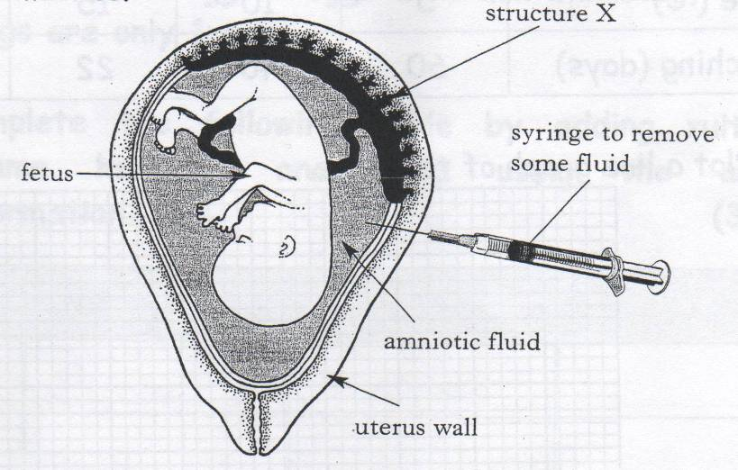
(i) Name the procedure described above. (1)

(ii) The fetus receives food through structure X. (1)
State the source of this food.

2. The diagram below shows the newly hatched young of a trout
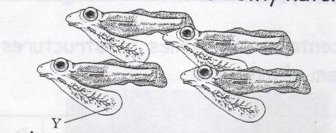
KU | PS

Y

(a) Give the name and the function of the structure labeled Y
Name ___________________________ (1)

Function ___________________________ (1)

(b) The following table shows the number of days from egg laying to hatching in trout at different temperatures.

Temperature (ºC) | 5 | 10 | 15 | 20
Time to hatching (days) | 60 | 40 | 22 | 5

(i) Plot a line graph of the data. (2)
Temperature (ºC)

(ii) What is the effect of increasing the temperature on hatching time? (1PS)
KU | PS

Pike, roach and trout are freshwater fish which reproduce by external fertilisation of their eggs.

Adult pike range from 100 to 150 cm in length and each female produces an average of 100 000 eggs which are each 2.5 mm in diameter.

Adult trout and reach are each from 25 to 40 cm long. Roach produce the same number of eggs as pike on average, whilst trout produce only 1000 eggs per female.

Trout produce the biggest eggs at 5 mm diameter, whilst roach eggs are only 1 mm.

(a) Complete the following table by adding suitable column headings and data using the above information. (3PS)

Fish
Pike
Trout
Roach

(b) Which species has the greatest chance of successful development? Give a reason for your answer. (2)

Species ___________________

Reason

(c) Fertilisation in land living animal is internal. Explain the importance of this. (1)
KU | PS

4. The table below refers to reproduction in the trout (a fish) and the whale (a mammal). Tick the correct box for each statement to show whether it refers to the trout or the whale. (2)

Statement | Trout | Whale

Embryo obtains food from the mother’s blood

Young emerges from eggs, able to look after themselves

Sperm are deposited in the water near to the eggs

Fertilisation takes place in the oviducts

Homework Exercise 6 Water and Waste
KU | PS

1. (a) The diagram below shows a healthy human kidney. 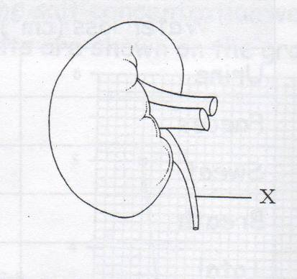
Name the structure labelled X on the diagram. (1)

(b) Complete the following sentences using the words from the box. Each word may be used once¸ more than once or not at all. (2)

Vein | Artery | Glucose | Protein | Excreted | Reabsorbed

Blood is taken to the kidneys in the renal _______________. In the kidney _______________ is filtered out of the blood and then ______________.

- Humans will die if water loss reaches 20% of body weight.
What weight of water loss would result in the death of a person weighing 70 kg?

Weight loss ___________kg (1P)
(d) Complete the table below to show the gains and losses of water by a small mammal each day. (1PS)
KU | PS

Water loss (cm³)
Urine | 300
Faeces
Sweat | 100
Breath | 78
Total | 500

Water gain (cm³)
Food | 170
Drink
Chemical reactions | 70
Total | 500

2. The grid below contains words about the kidneys.

Renal artery | Renal vein | Urea
Filtration | Ureter | Glucose
Bladder | Reabsorption | Urine

Use words from the grid to complete the following sentences correctly.

(i) The ________________________ brings blood to the kidney and the _______________________ takes blood away from the kidney. (1)

(ii) The kidneys are the main organs for regulating the water content of mammals. Their method of action involves ______________________ of blood followed by _____________________________ of useful substances. (1)
(iii) ______________________ is a waste product which is removed in the _____________________. (1)
KU | PS

3. A volunteer was given 1 litre of water to drink. Every 30 minutes for the next 3 hours, urine was collected and its volume and salt concentration were measured.
The results are shown on the graph below:
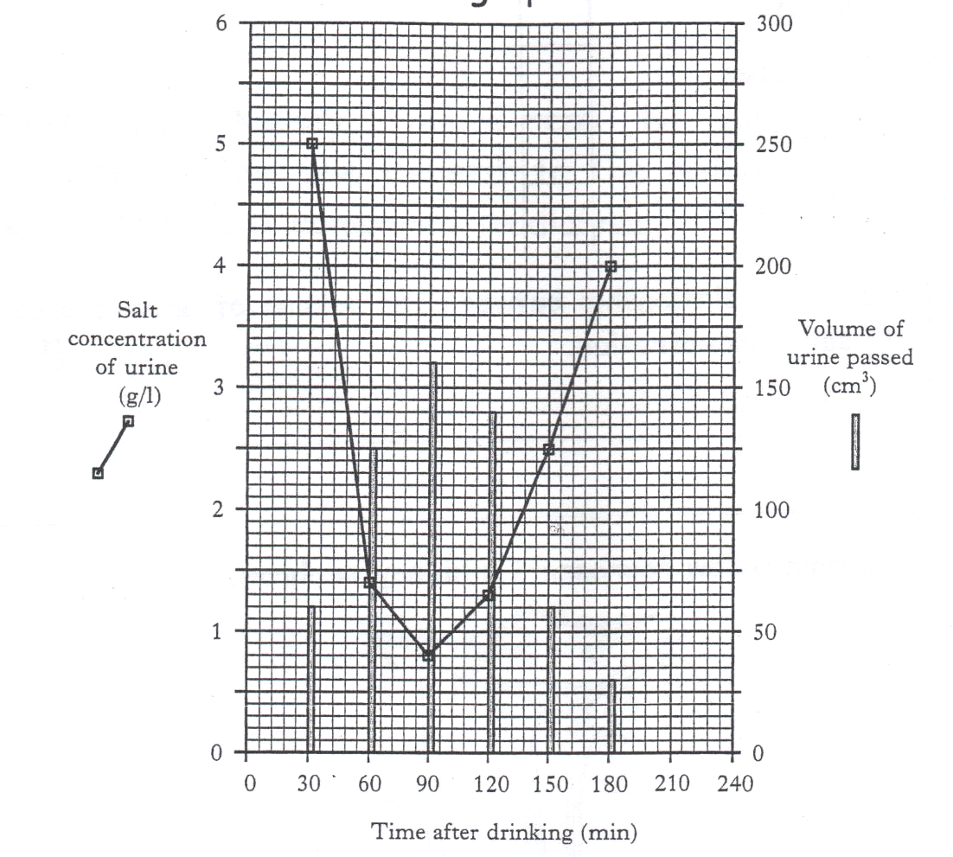
- What was the total volume of urine passed during this investigation? (1)

___________ cm³

(b) Using the data in the diagram, predict the salt concentration of a urine sample taken at 210 minutes. (1)

______________g/l

(c) Between which two sample times would the volunteers’ blood have contained the lowest concentration of ADH? (1)
KU | PS

Tick the correct box

0 – 30 minutes
30 – 60 minutes
60 – 90 minutes
90 – 120 minutes

(d) Describe the relationship between the volume of urine passed and its salt concentration. (1)

4. (a) The diagram below represents a kidney nephron.

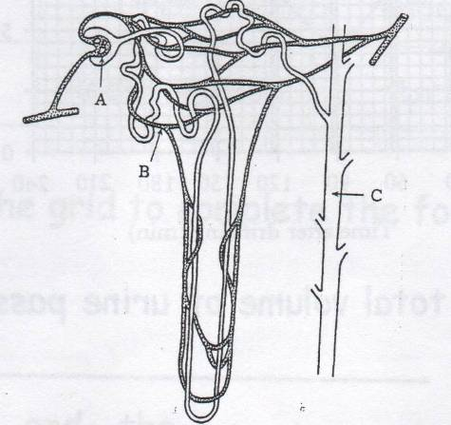
Complete the table by adding the correct letters, name and function. (2)

Letter | Name | Function
 | Collecting duct | Collects urine
A |  | Filters the blood
 | Blood capillary
5. One of the impurities removed from the blood is urea.
KU | PS

From which food component is urea produced? (1)

6. People with kidney failure can be given a kidney transplant. Give one benefit to the patient of having a kidney transplant compared to dialysis. (1)

Homework Exercise 7 Responding to the Environment
KU | PS

1. What are the three environmental factors which affect animal’s behaviour? (3)

2. Animals must respond to these environmental factors in order to survive.

Complete the following table. (6)

Animal | Environmental Stimulus | Benefit of the animals response

Woodlouse
Paramecium
Blowfly maggots

3. What is a choice chamber? (1)

4. How is rhythmical behaviour started? (1)
KU | PS

5. When studying the behaviour of woodlice, why is it important to look at large sample rather than just one woodlouse? (2)

