

Paisley Grammar School Biology Department

Standard Grade Biology



Biotechnology Homework Booklet

Name
Teacher
Homework | Date Due | Comment
Homework 1: Living factories
Homework 2: Living factories
Homework 3: Problems with profit and waste
Homework 4: Reprogramming microbes
HOMEWORK 1: GENERAL LEVEL
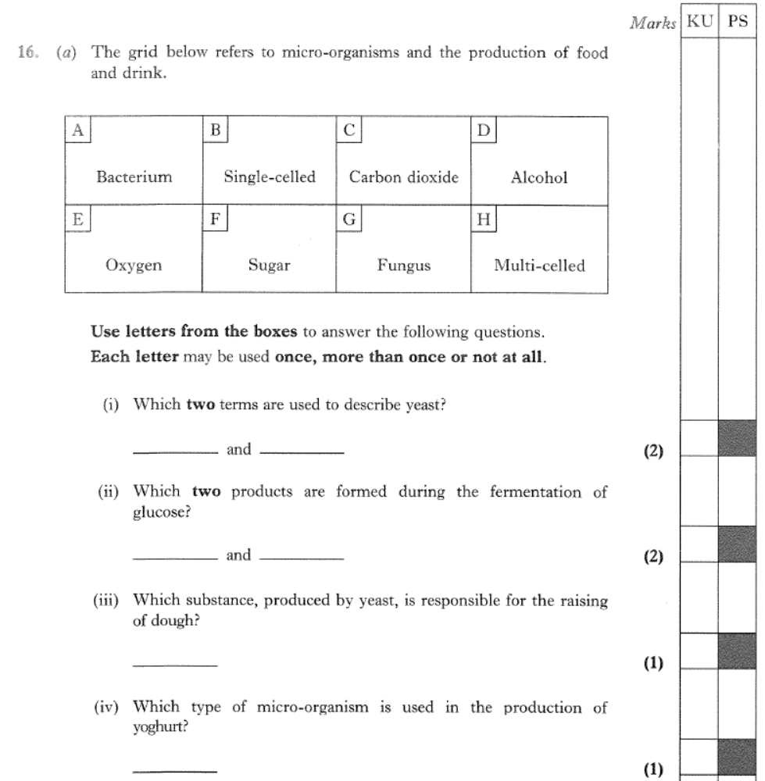
1.
1.
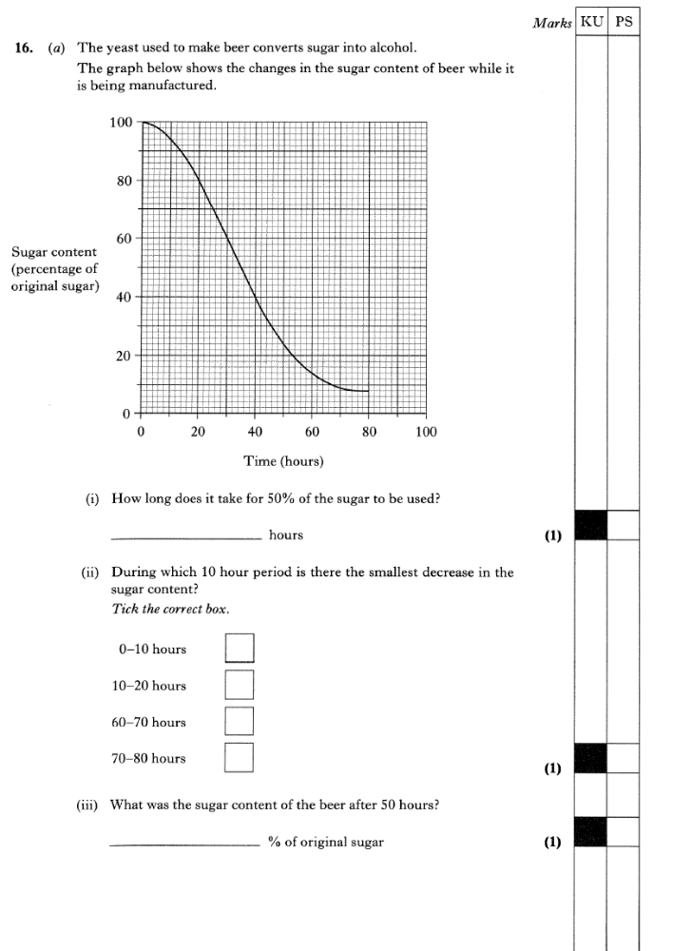
2.
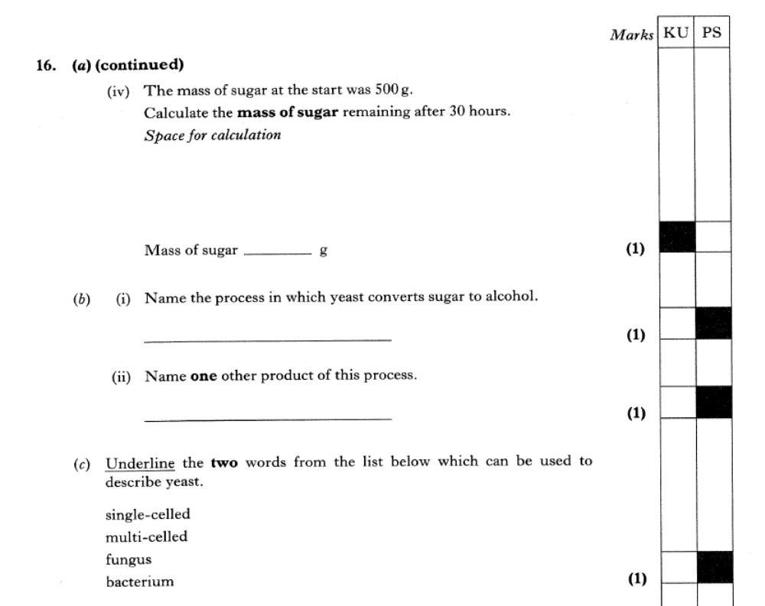
2.
HOMEWORK 1: CREDIT LEVEL

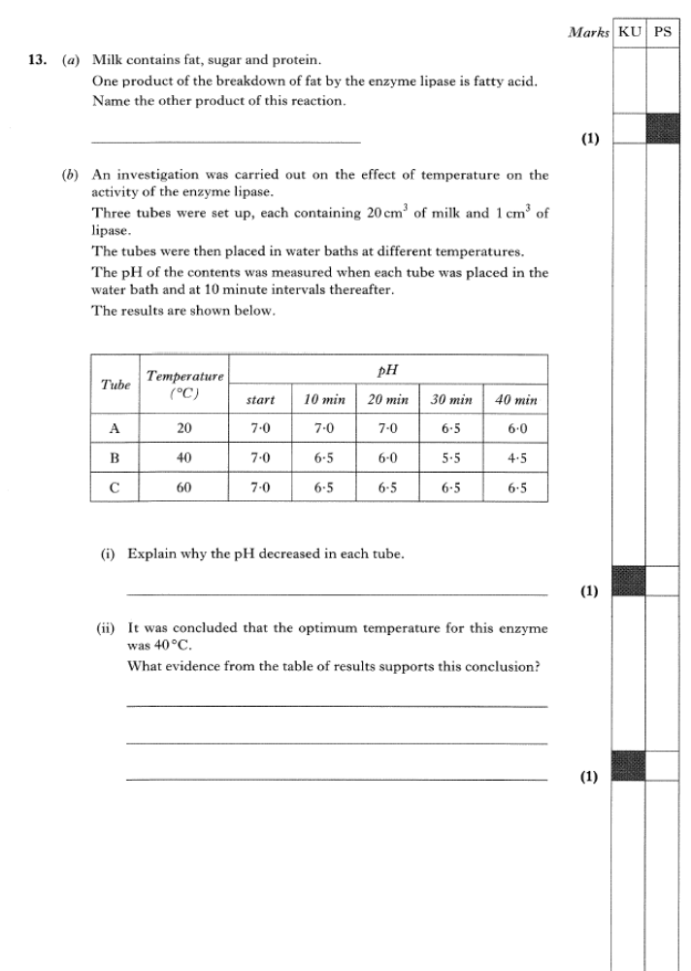
1
1.

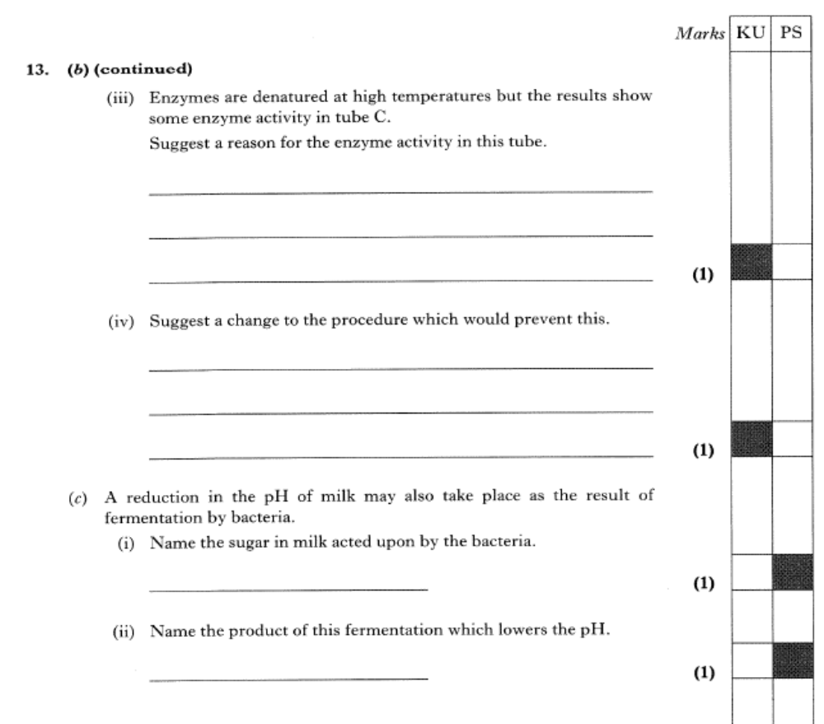

1.
HOMEWORK 2: GENERAL LEVEL
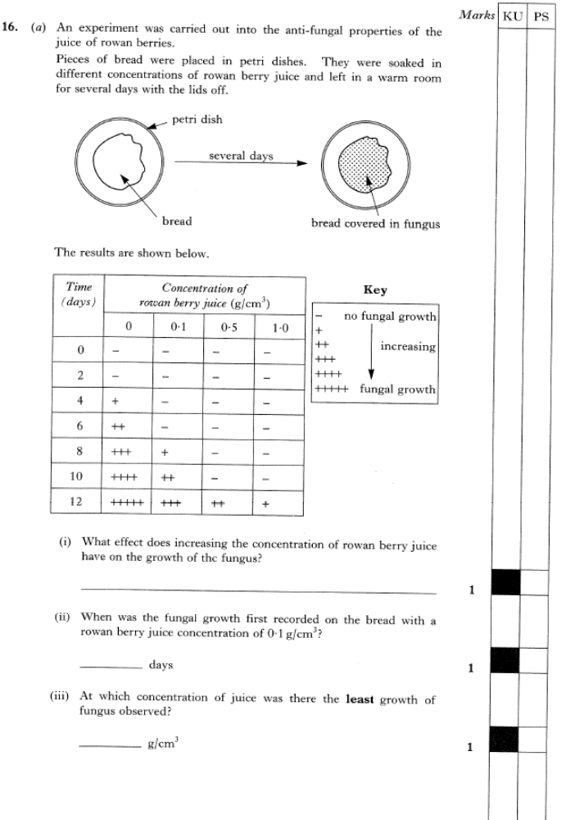
1.
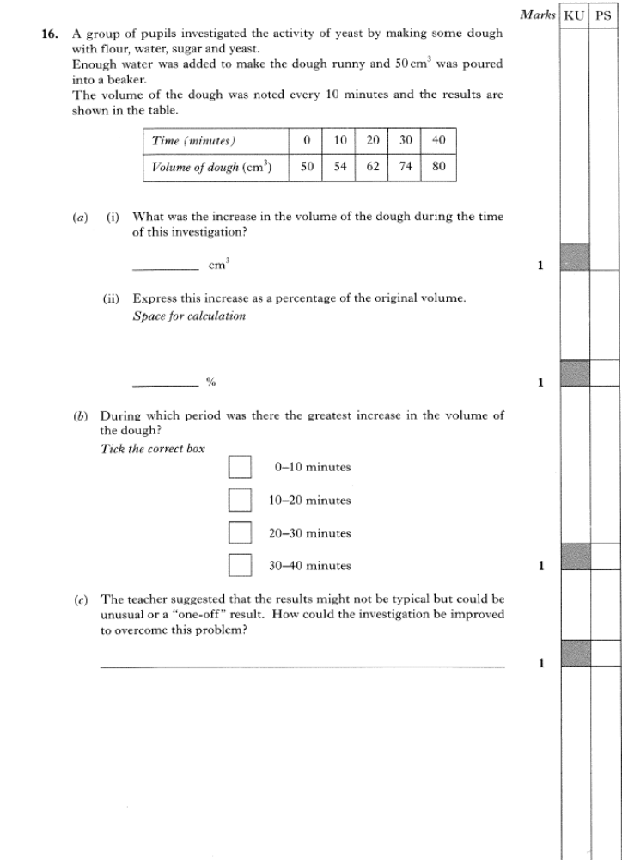
2.
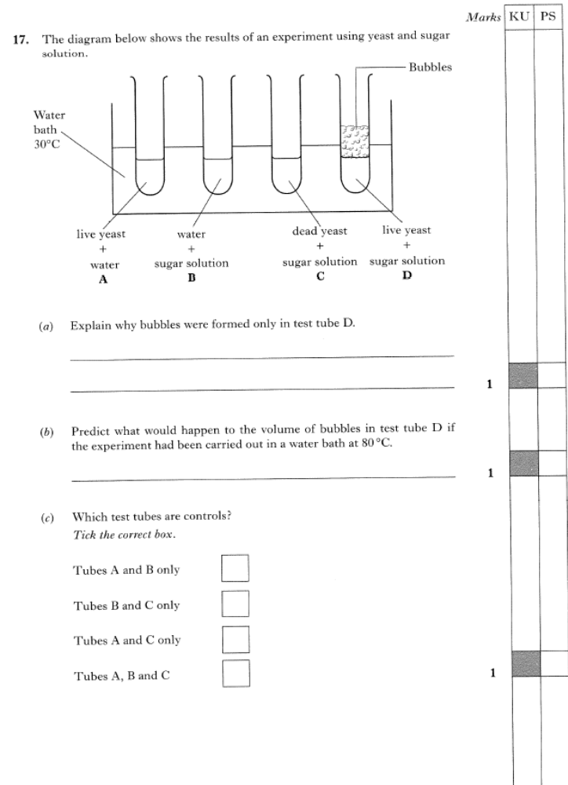
2.
3
3.
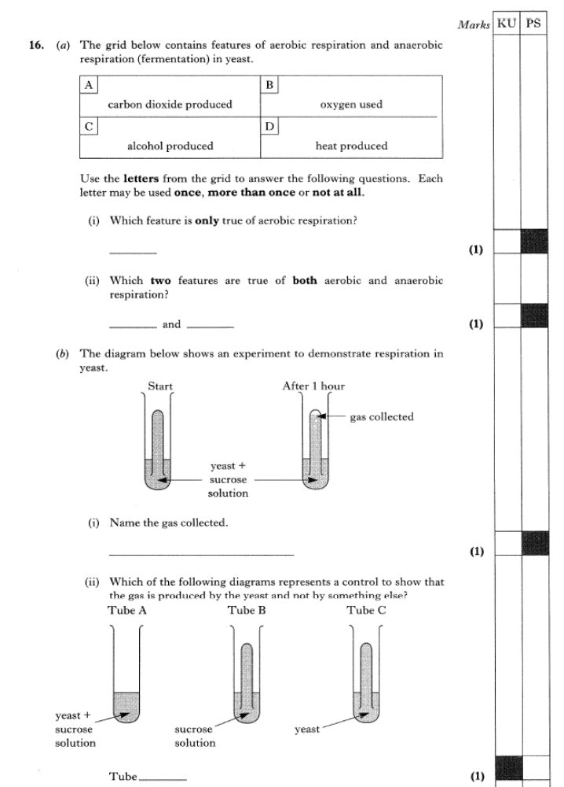
4.
HOMEWORK 2: CREDIT LEVEL
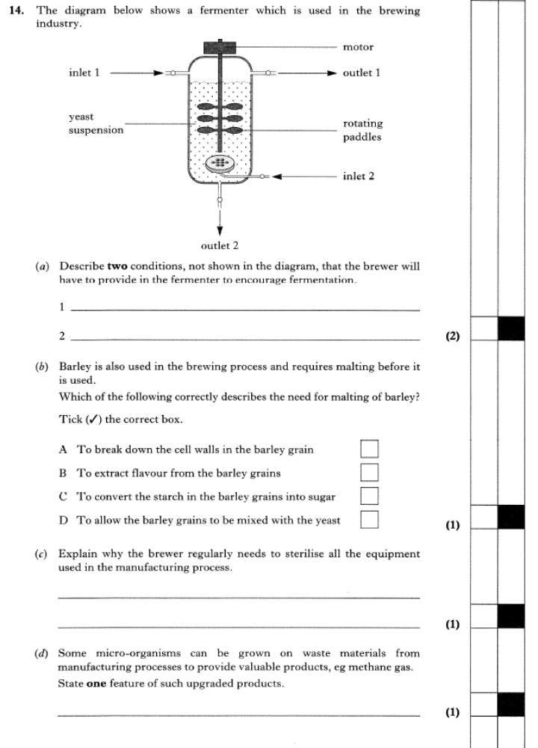
1
1.
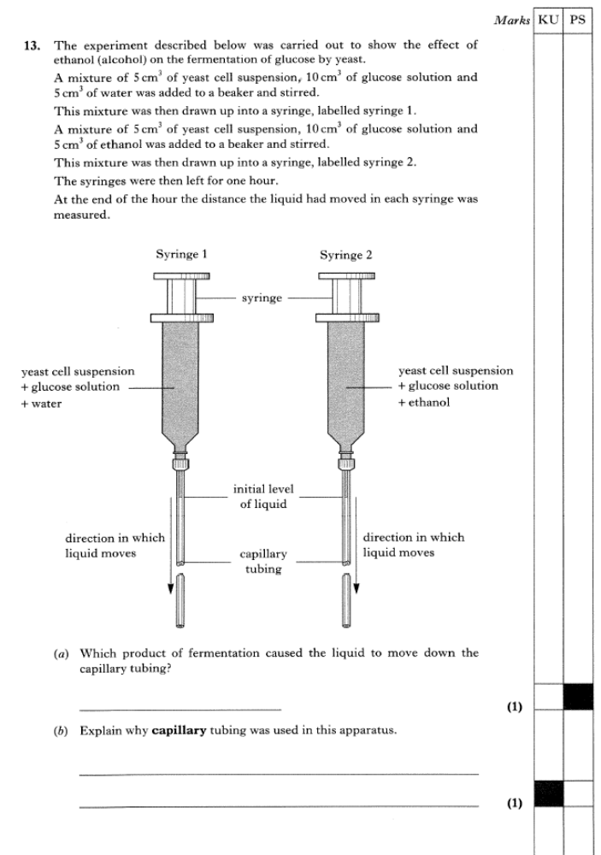
2.
HOMEWORK 3: GENERAL LEVEL
1.
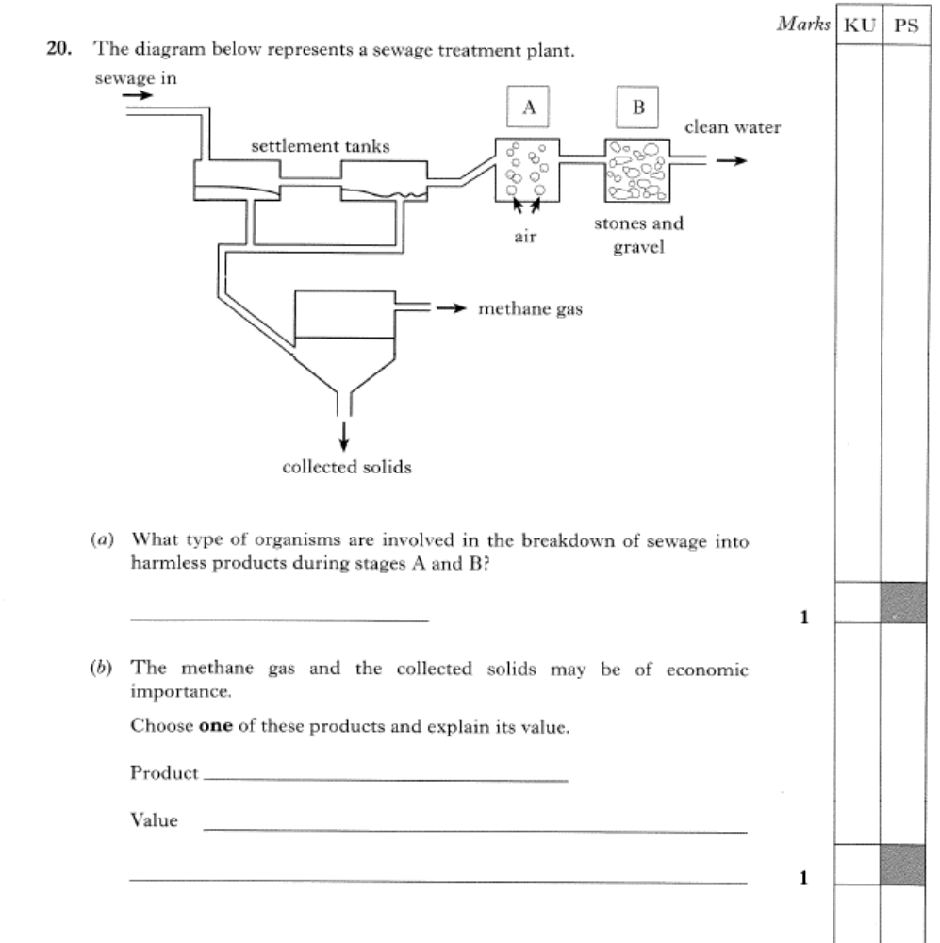
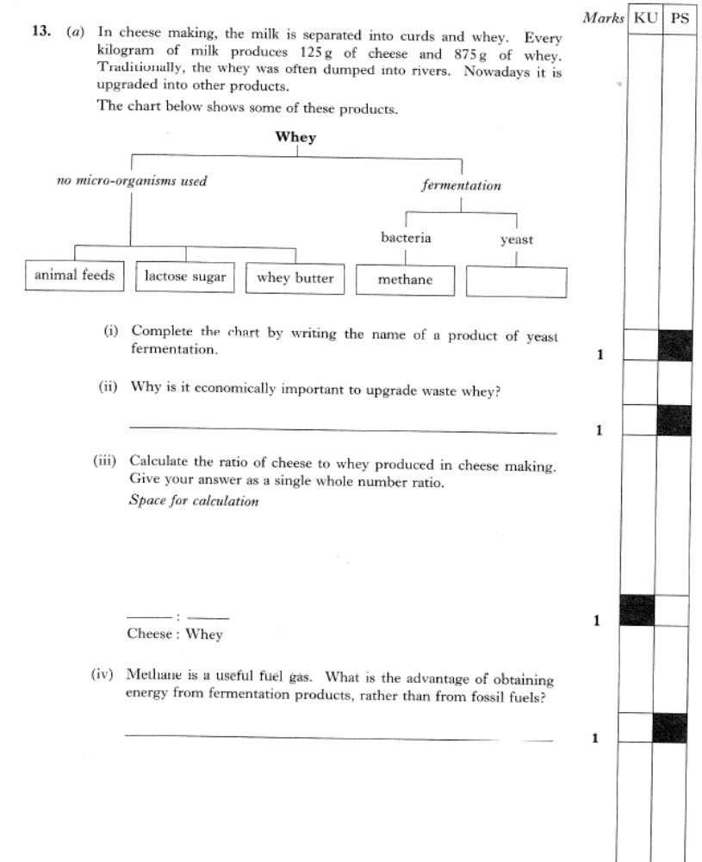
2.
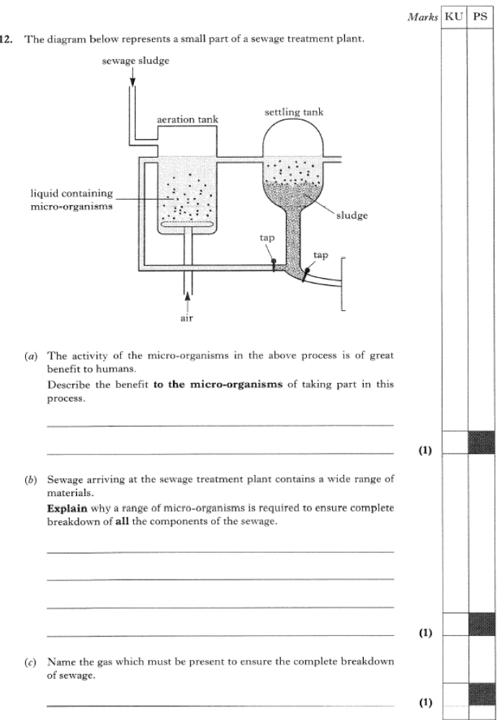
HOMEWORK 3: CREDIT LEVEL
1.
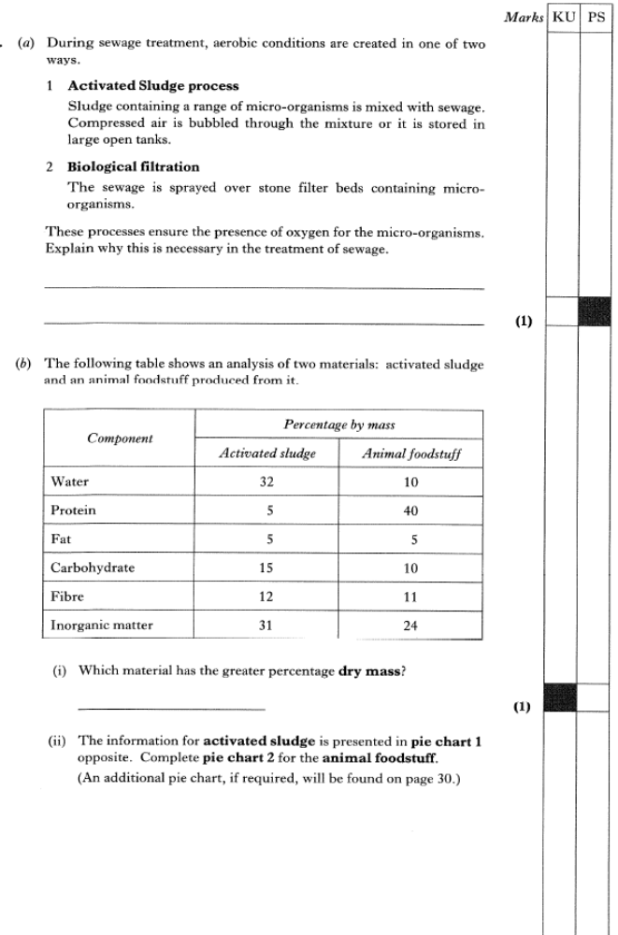
2
2.

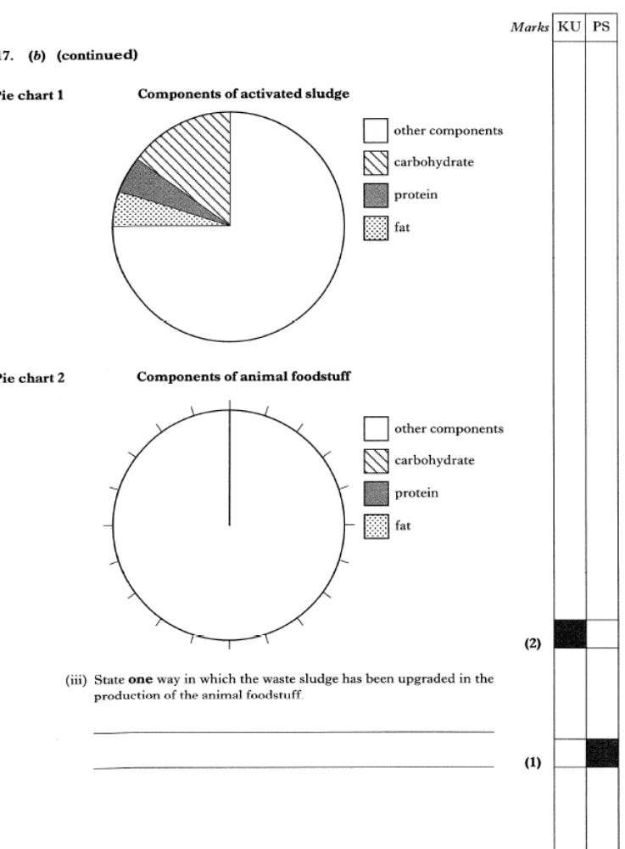
2.
HOMEWORK 4: GENERAL LEVEL
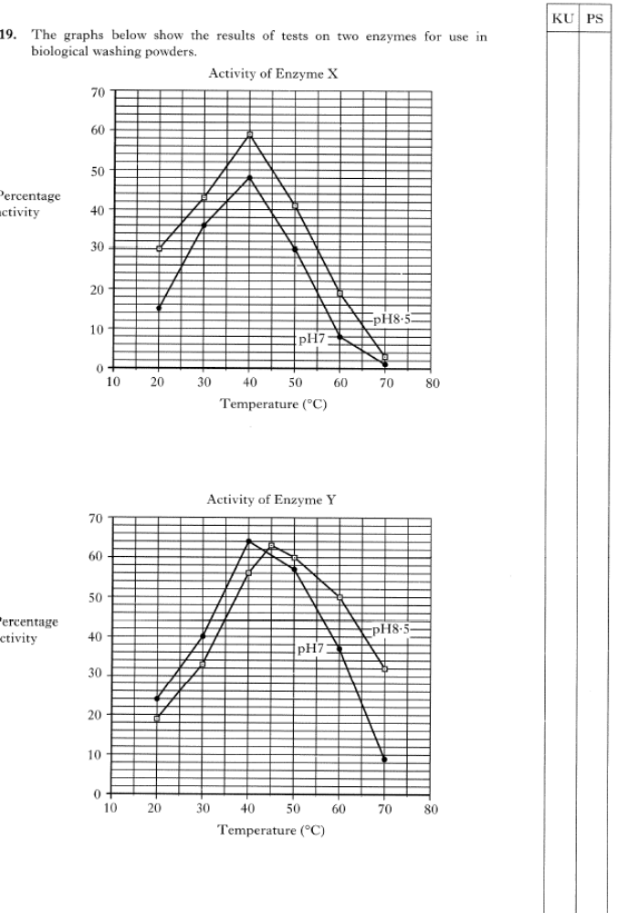
1.
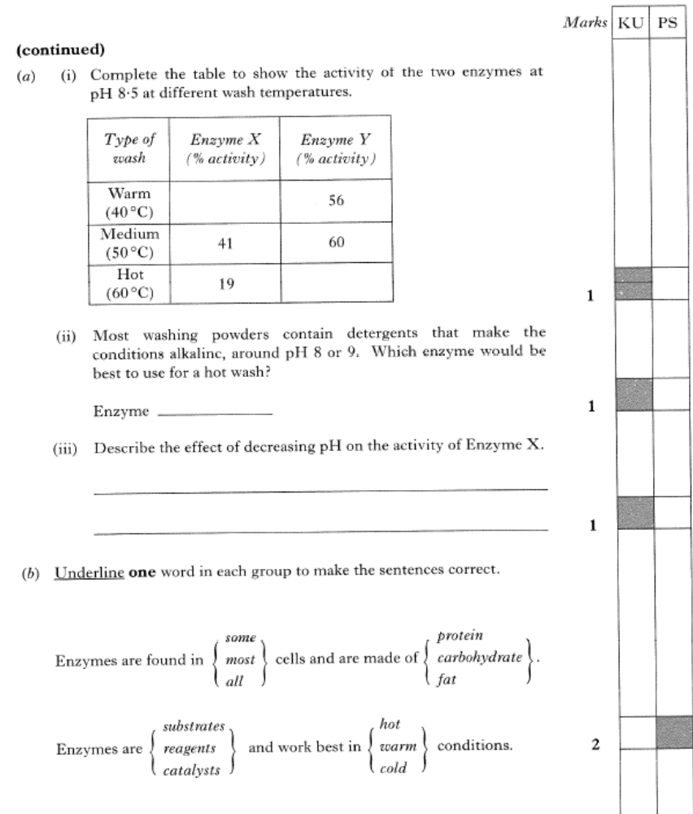
1.

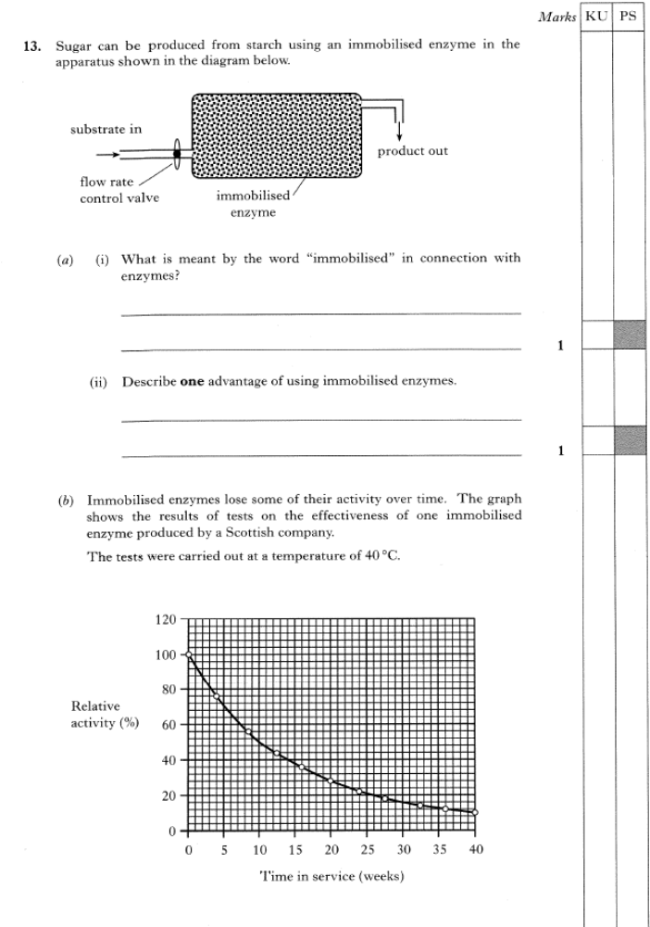
HOMEWORK 4: CREDIT LEVEL
1.
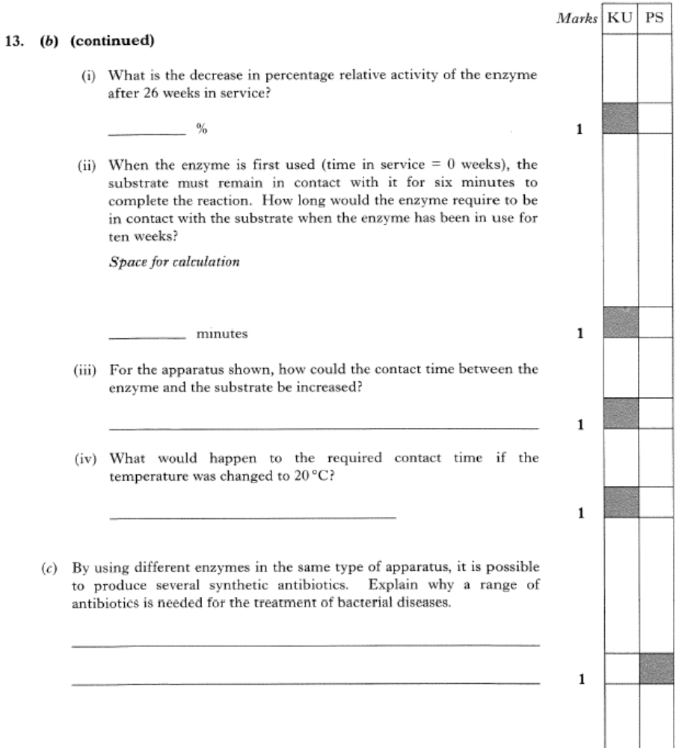
1.
1
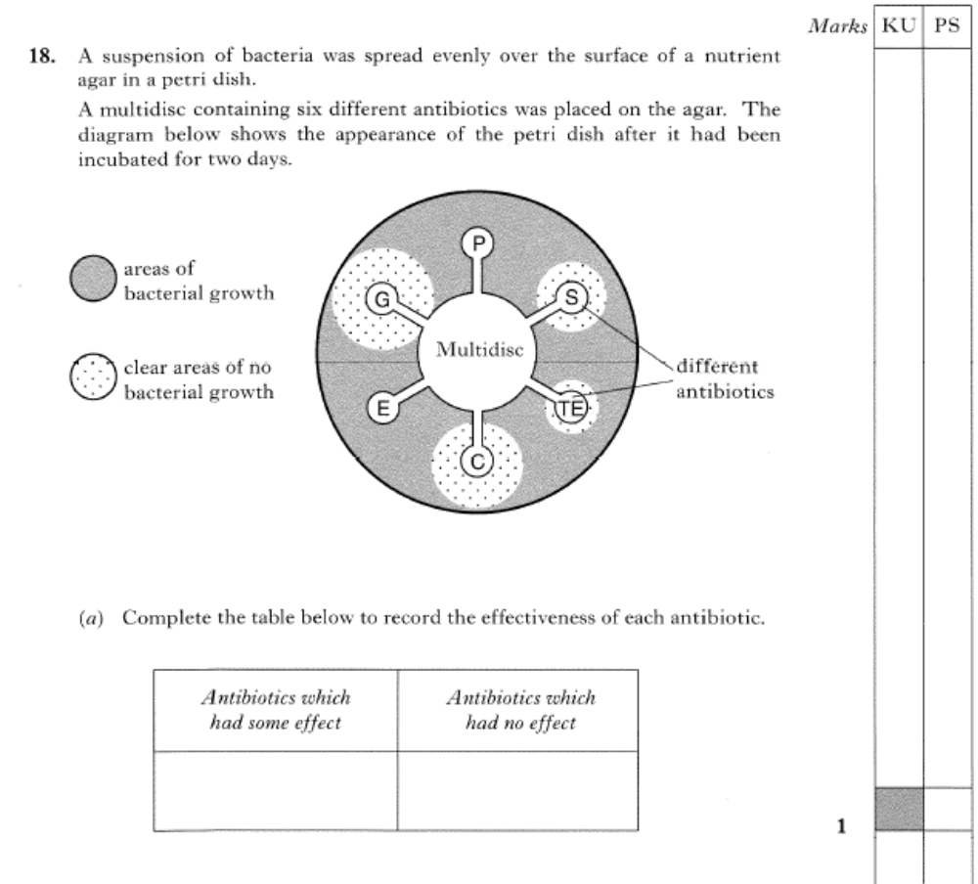
2.
2

