
Paisley Grammar School
Biology Department

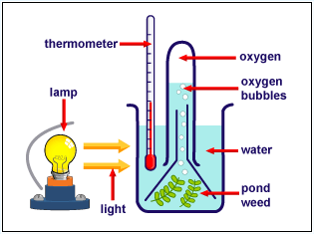

How to improve your
Problem Solving
GENERAL
The Biology exam has two sections: Knowledge and Understanding and Problem Solving.

Knowledge and Understanding questions are based on the work you have studied in class.

Problem solving involves:
- Drawing tables,
- Drawing line graphs,
- Drawing bar charts
- Calculating averages,
- Calculating percentages and
- Ratios
- Drawing conclusions
- Making predications
- Practical abilities

Practical Ability Questions

Practical abilities involve looking at experiments and answering questions on them.

- Reliability is to do with the “believability” of the results (Repeating an experiment or using many organisms increases the reliability of its findings)
- Accuracy is taking precise measurements
- Fairness is correctness or validity. In a fair test only ONE variable is changed.
- When asked to state a variable that needs to be controlled in a future experiment you should:
  - Look to see what has been mentioned already (e.g. mass, volume etc)
  - Answer something that has NOT been mentioned (if the volume of liquid is mentioned you can answer “concentration”, if concentration is mentioned you can answer “volume”.
  - Variables that can be controlled are:
    - volume,
    - concentration,
    - mass,
    - time,
    - pH and
    - temperature

Control Experiments

A control acts as a comparison. It attempts to prove that it is the factor that was changed (e.g. temperature) that causes the results. A suitable control for Biology experiments is changing a solution for water or a living organism for a dead one.

Relationships

A relationship is how one variable affects another.

For example if a question was to ask what the relationship is between the temperature of the day and the number of ice-creams sold the relationship is:
“The higher the temperature, the more ice-creams are sold.”

Your answer should include both variables and if BOTH have increased or decreased.

You also need to be careful that the variables are in the correct order. Be aware of what variable affects the other. There is a difference between:

“The higher the temperature, the more ice-creams are sold.”
and
“As more ice-creams sold, the temperature increases”

GENERAL
2000
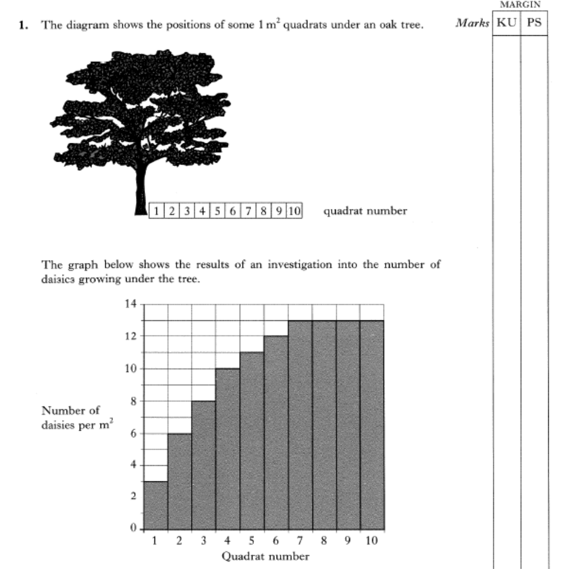

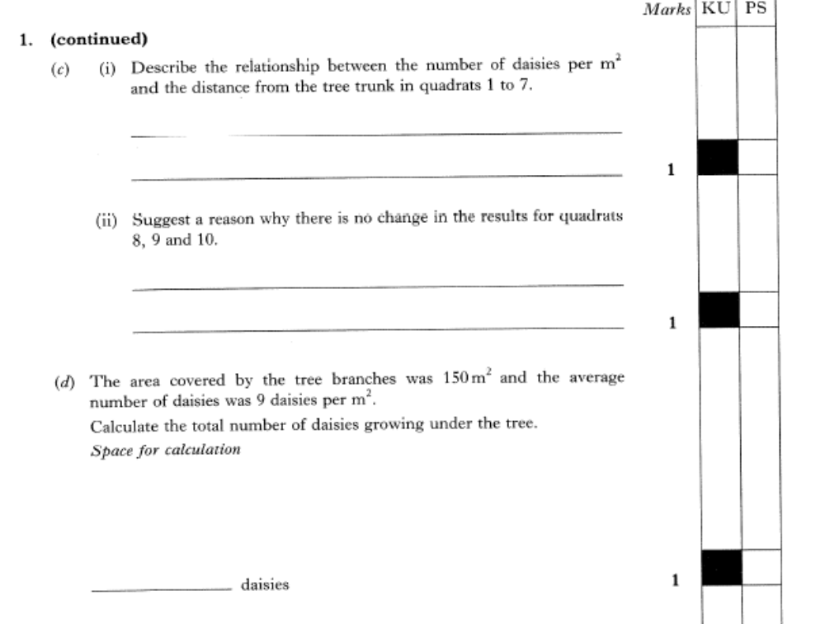

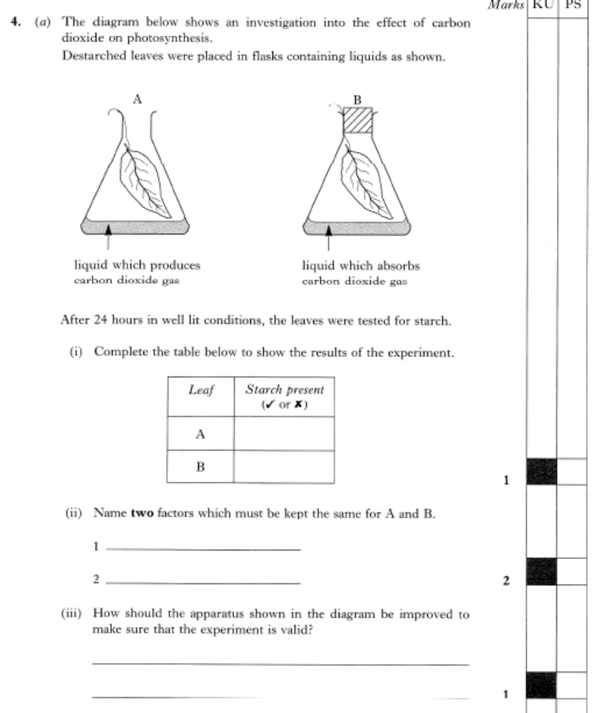
2001

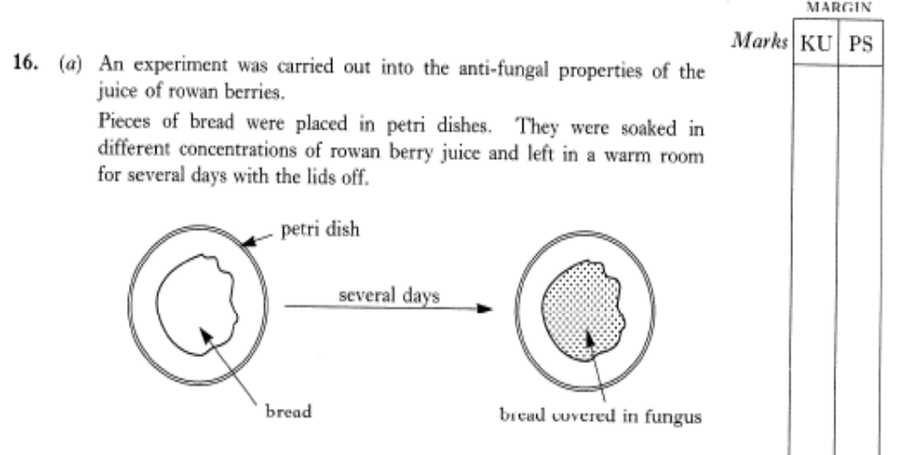
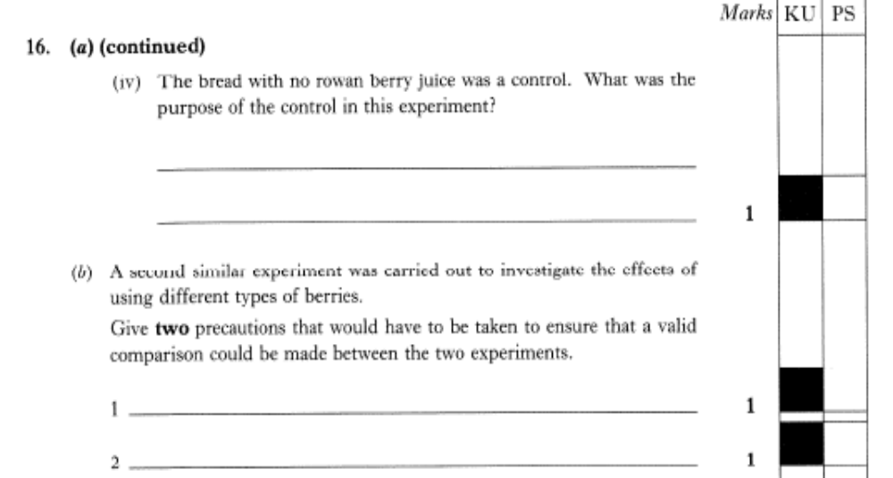
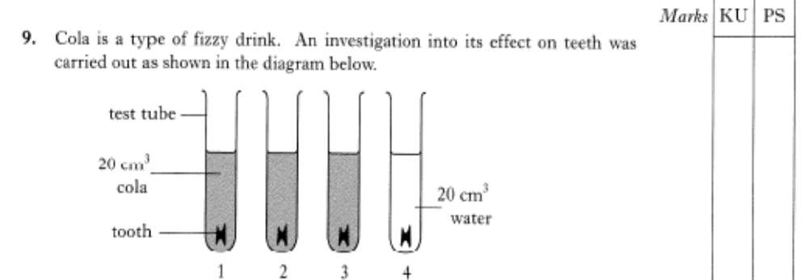
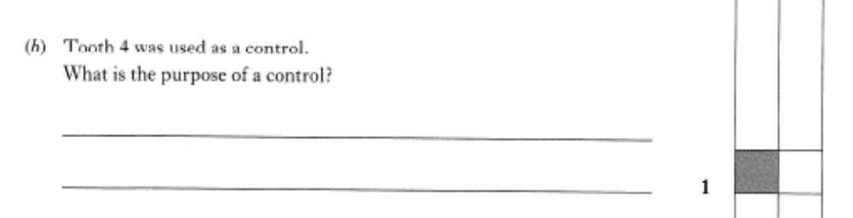
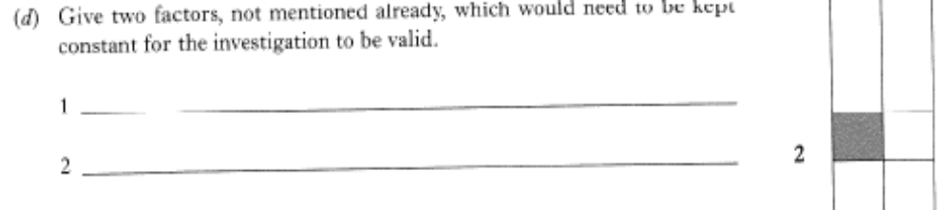
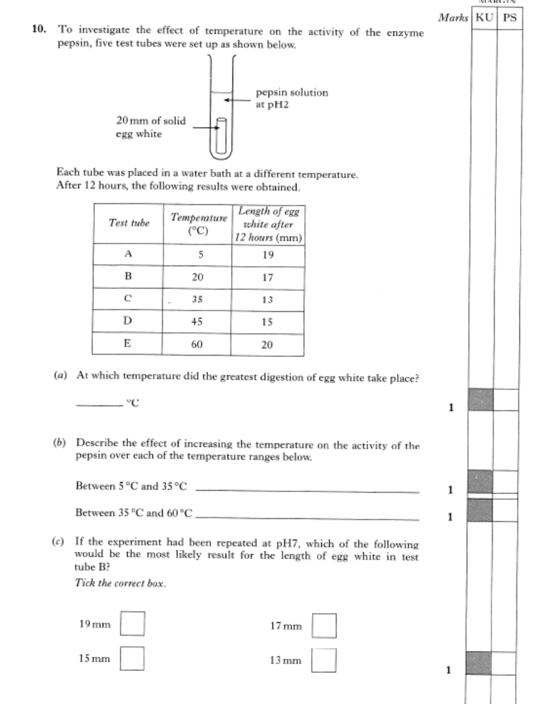
Be aware that the highest number doesn’t always mean the experiment has worked well.

2002
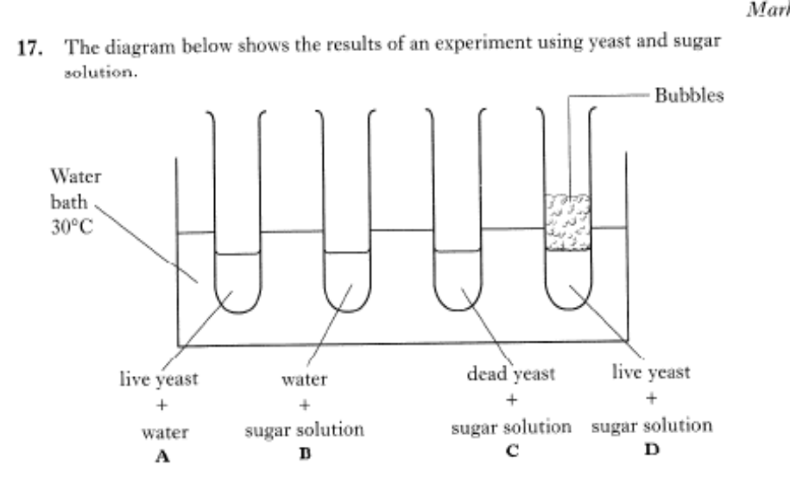
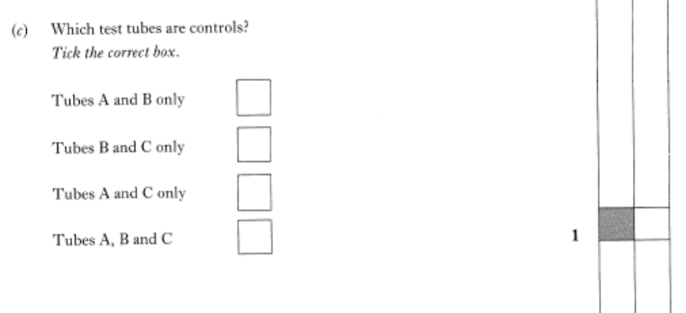

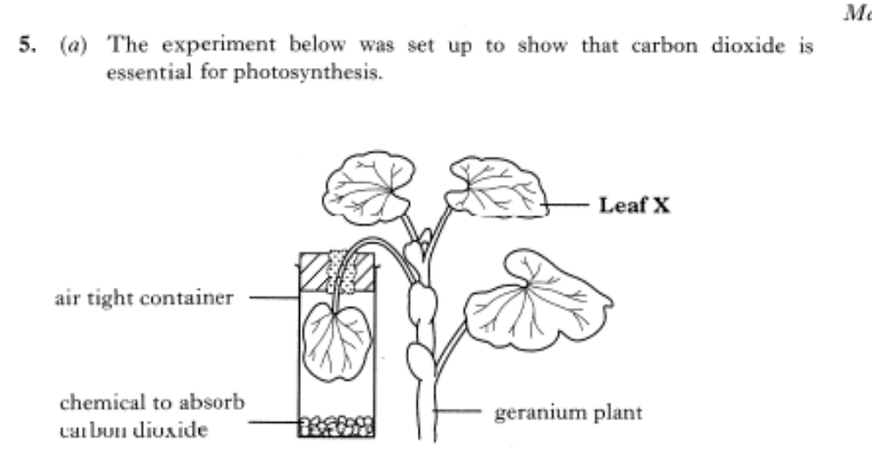
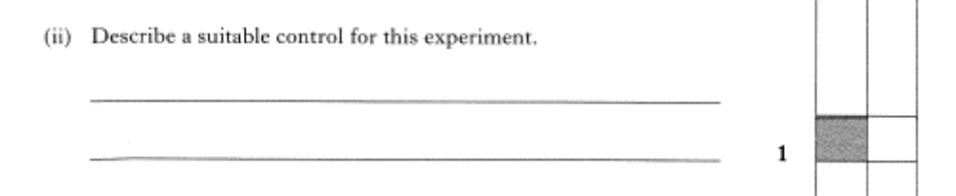
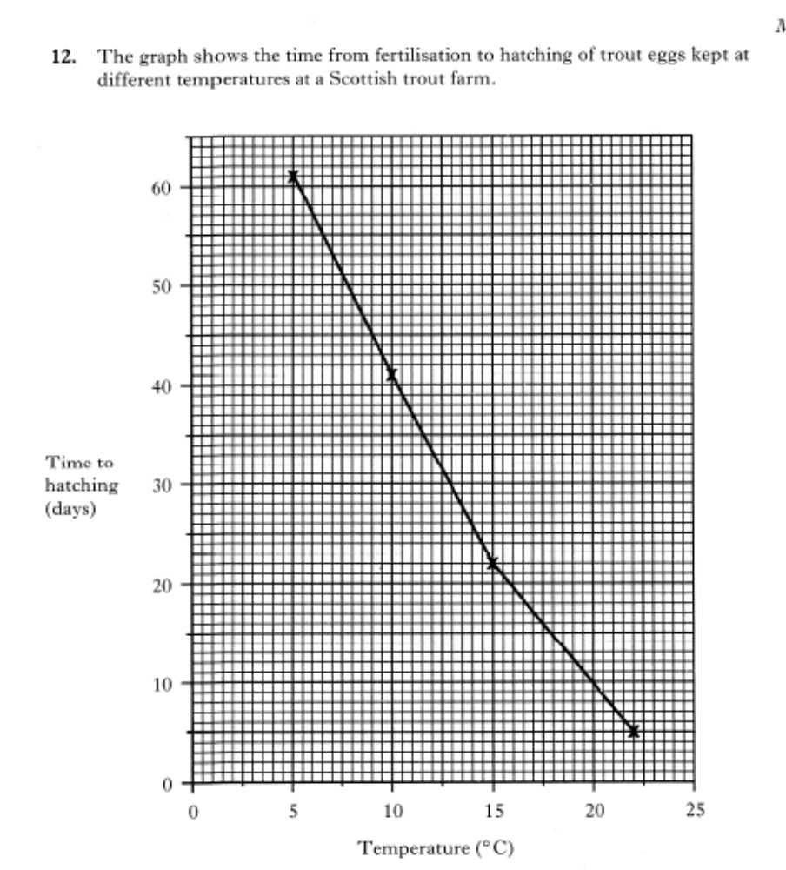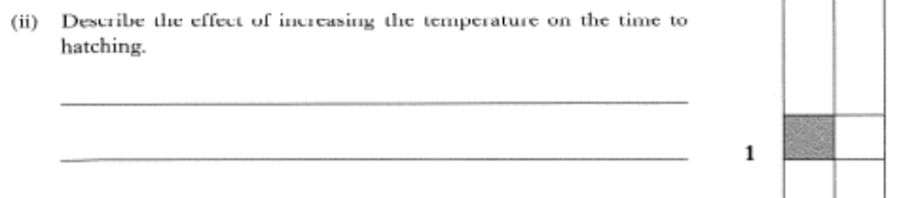
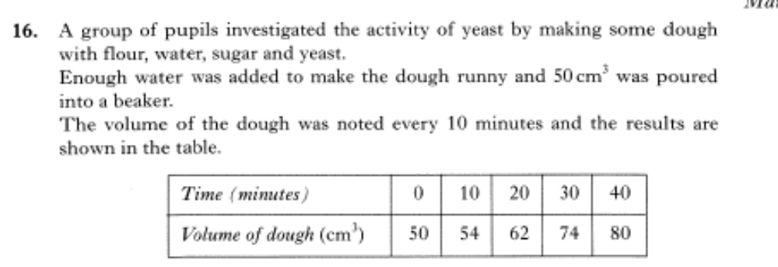
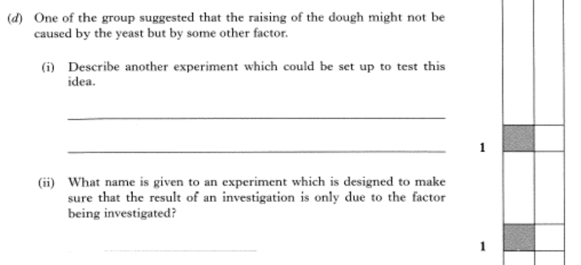
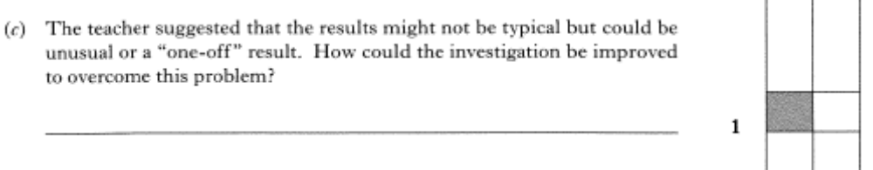
2003

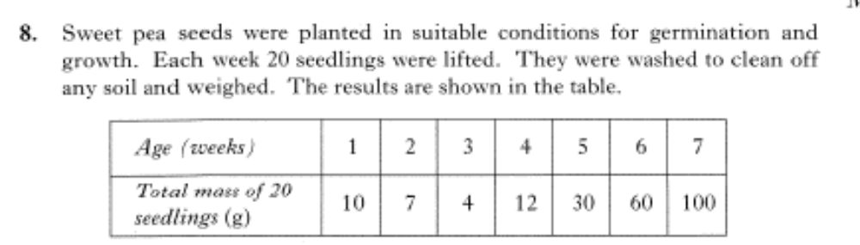
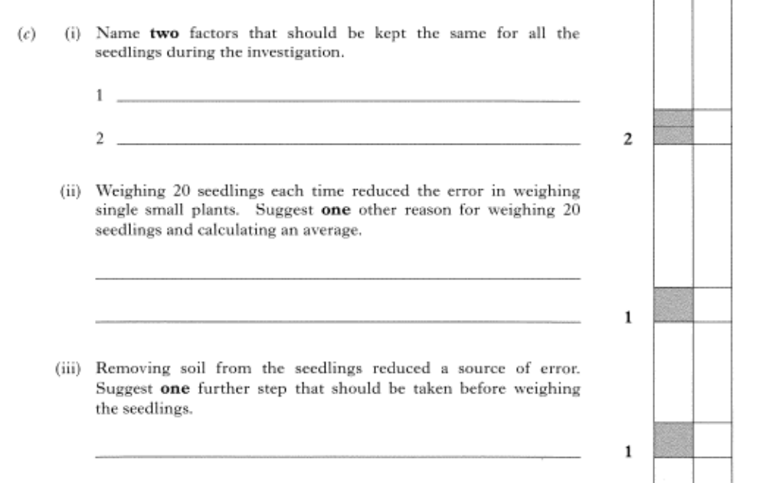
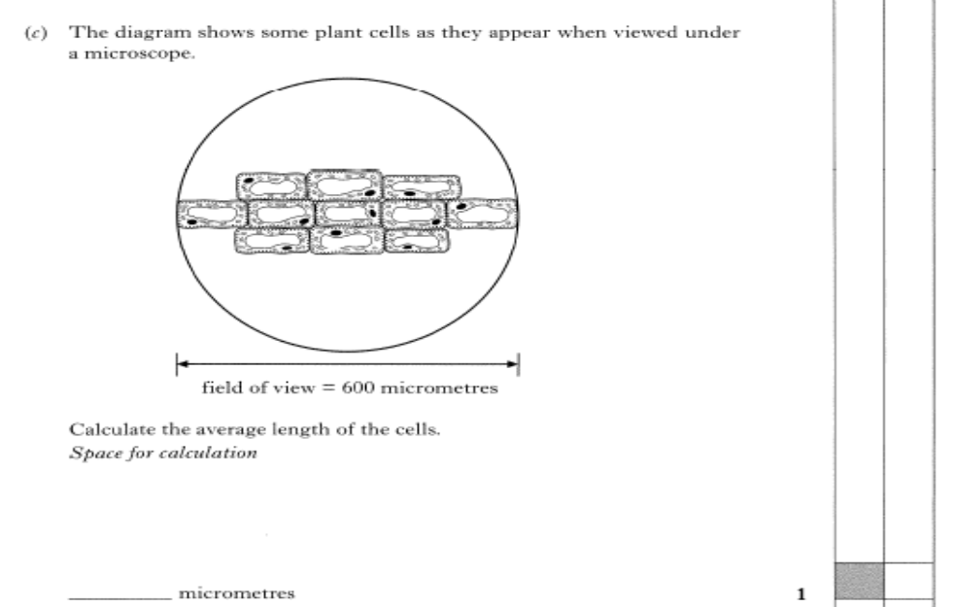

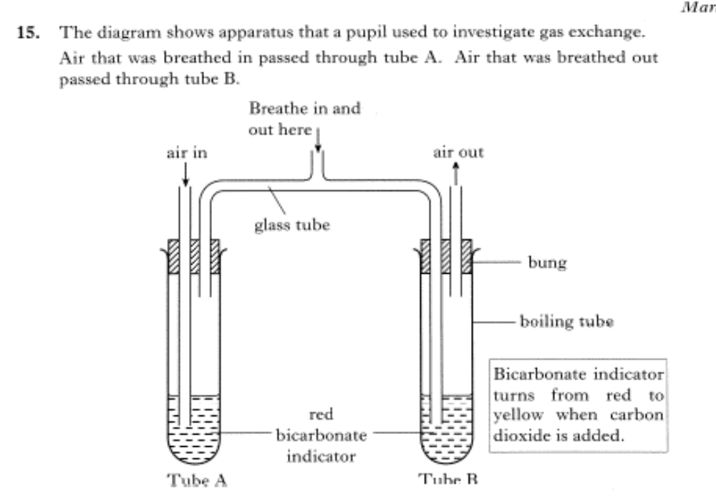
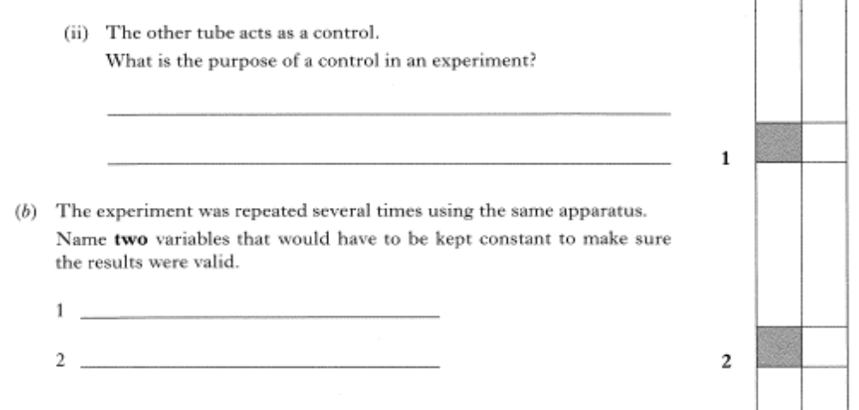
2004
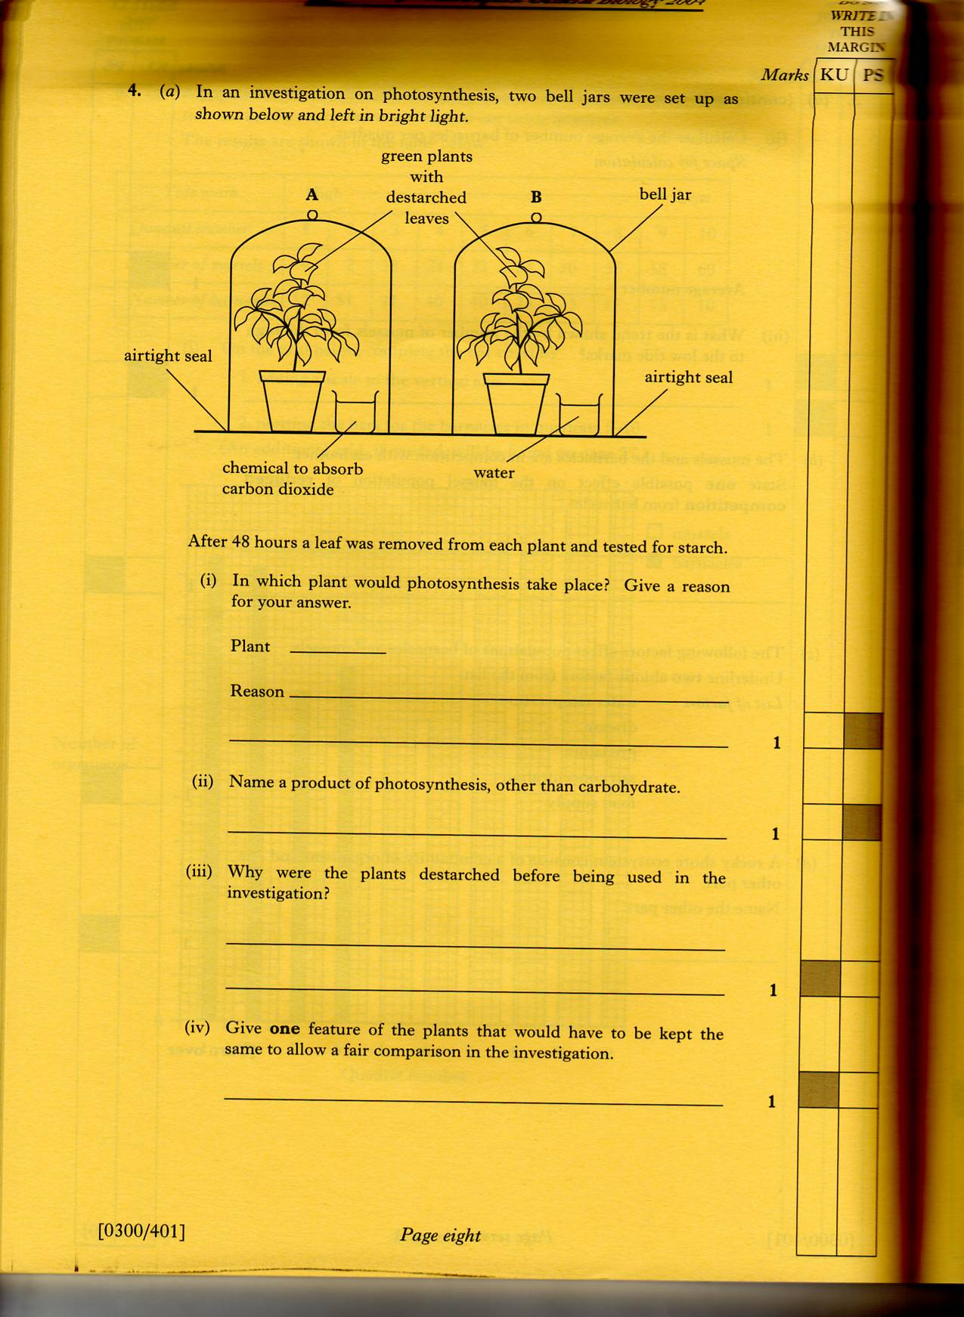

2005
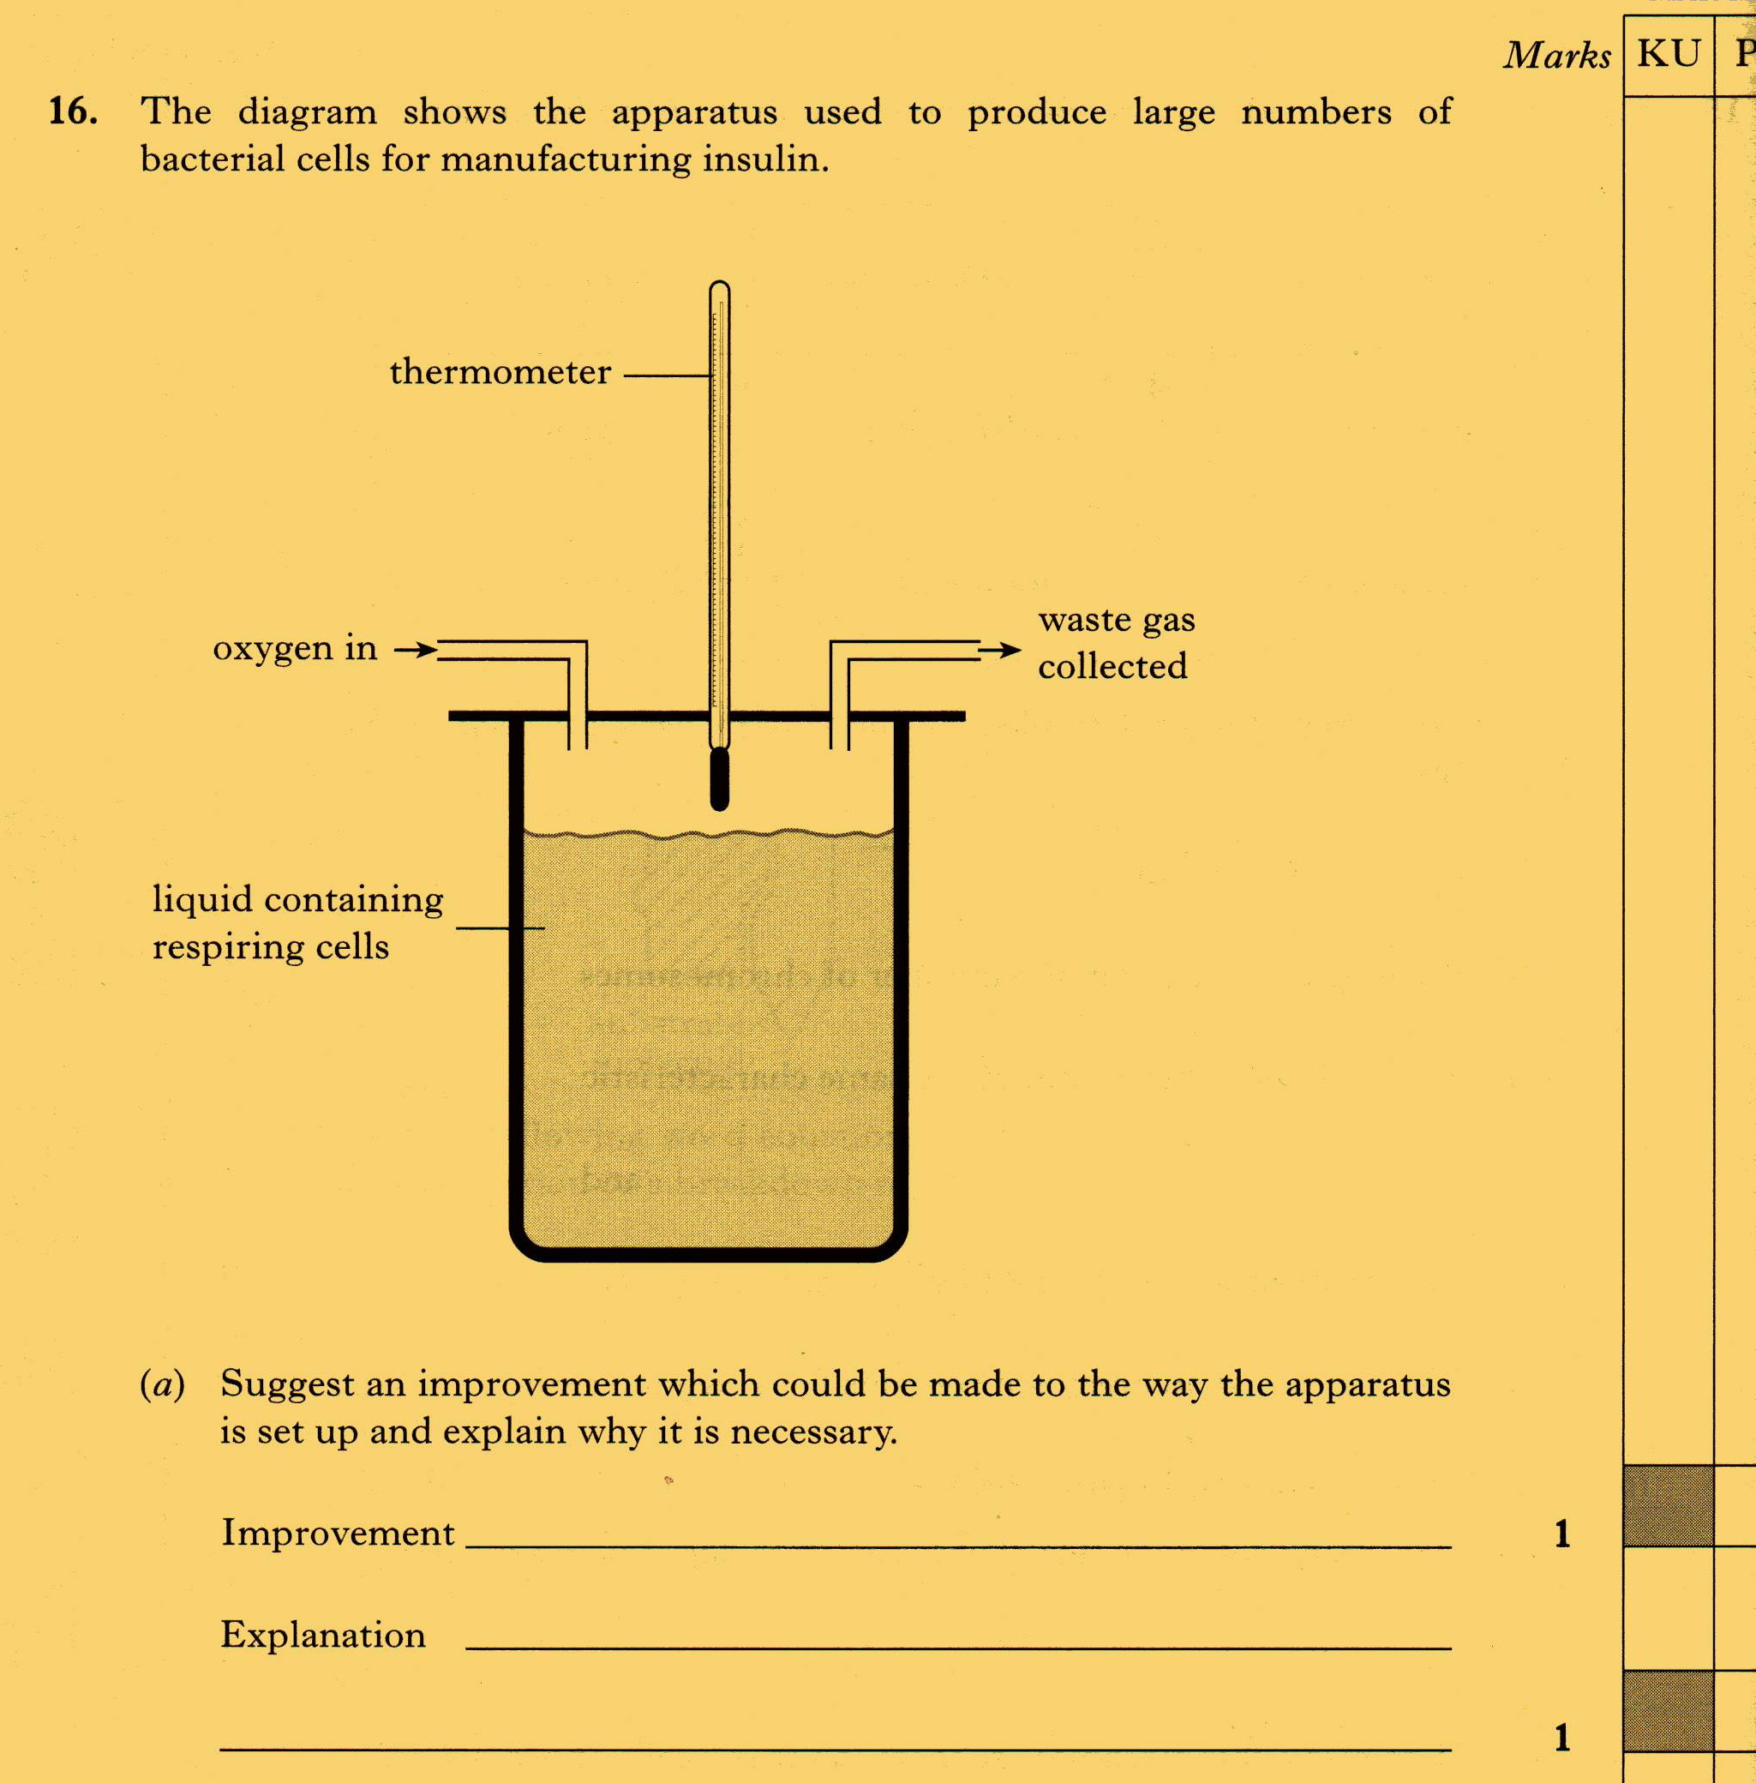

2006
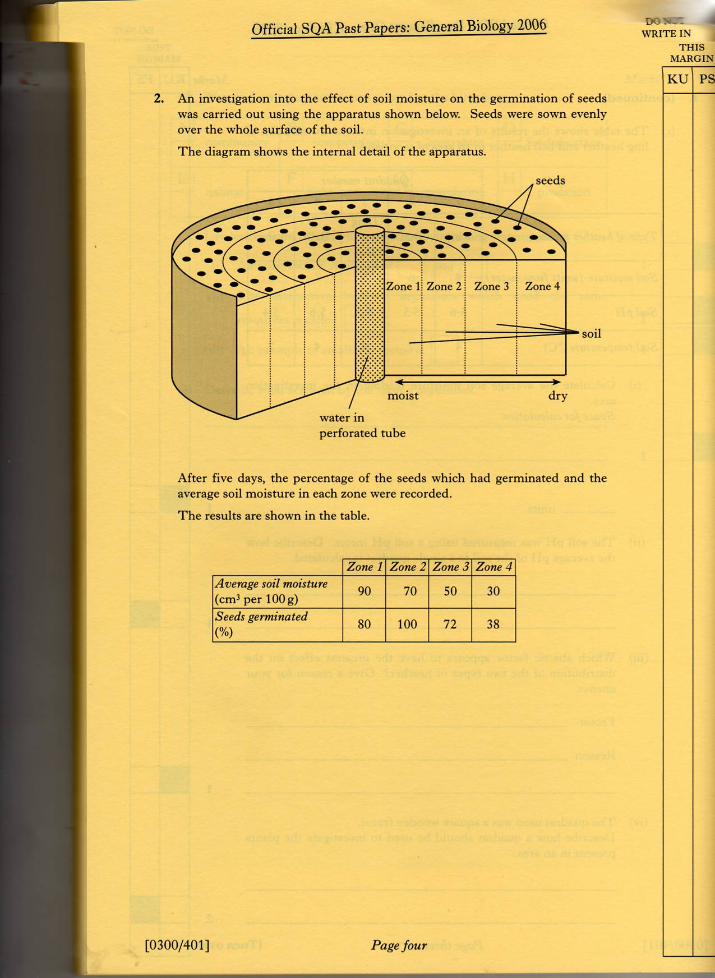
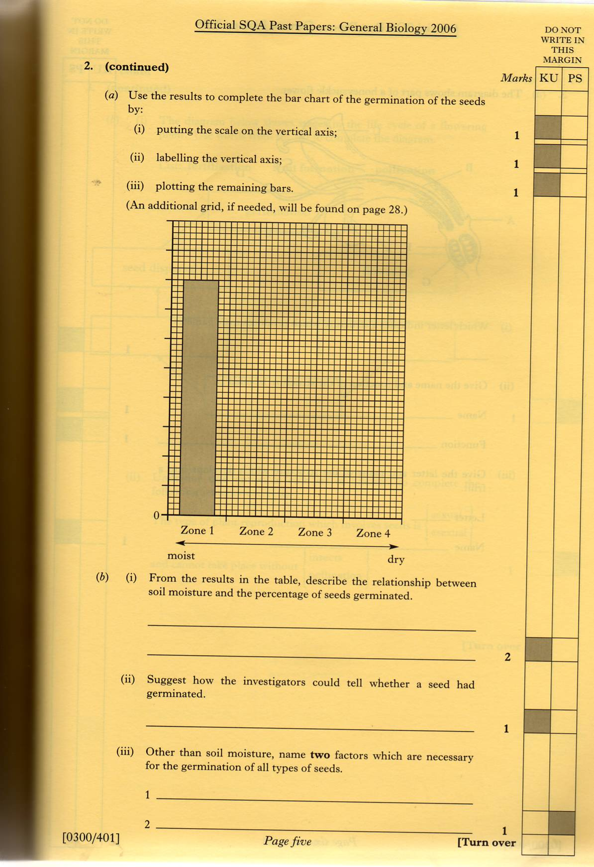
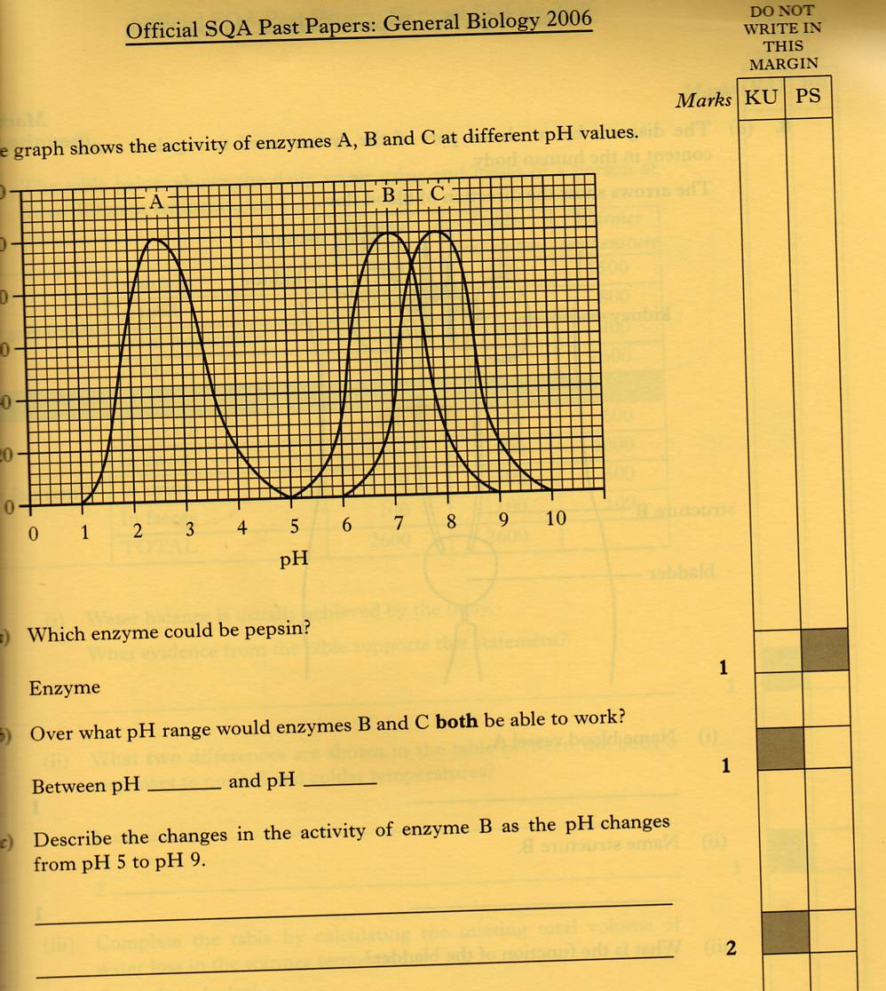
2007
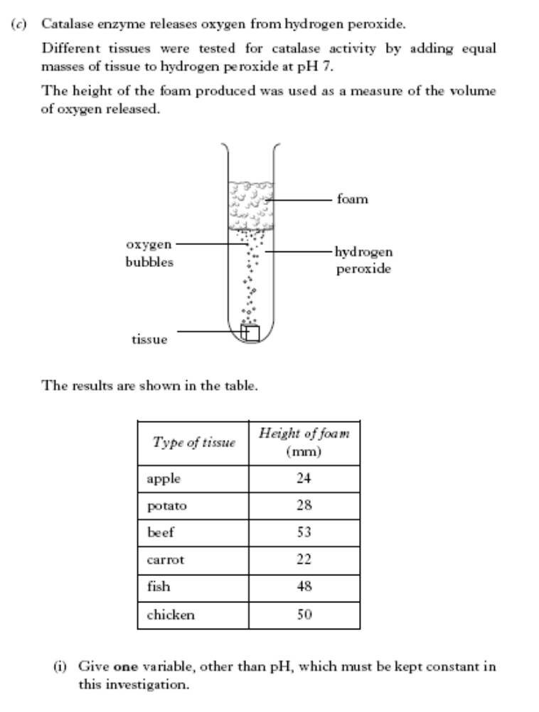

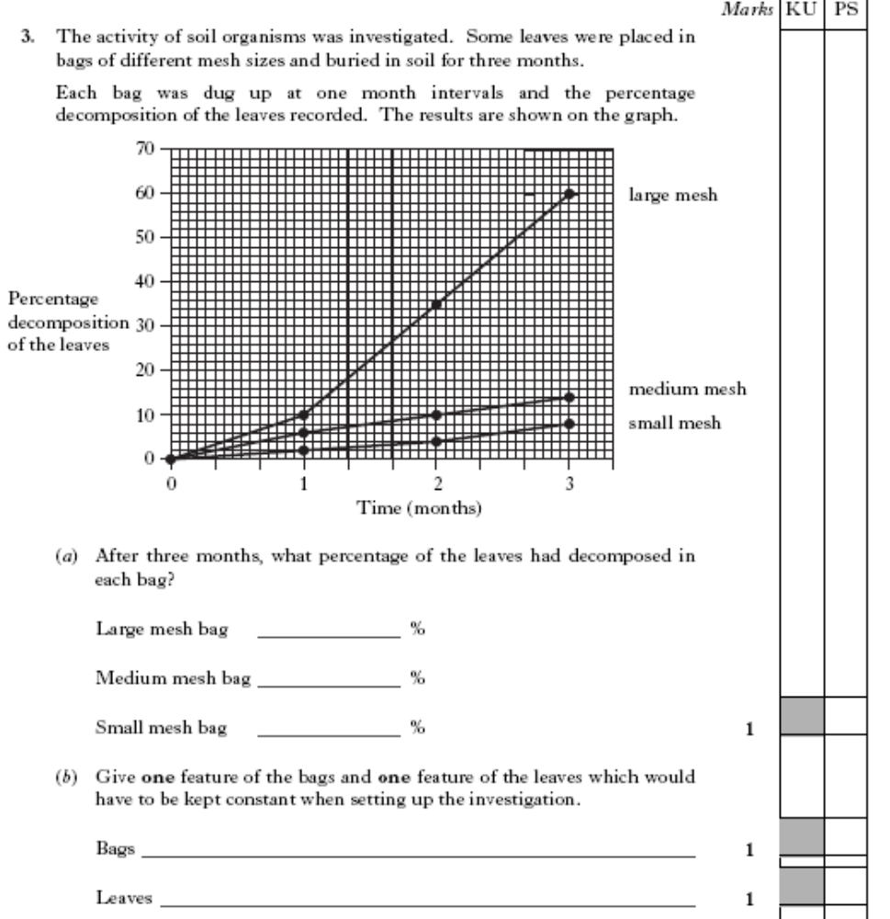
2008



