
Paisley Grammar School

Chemistry Department
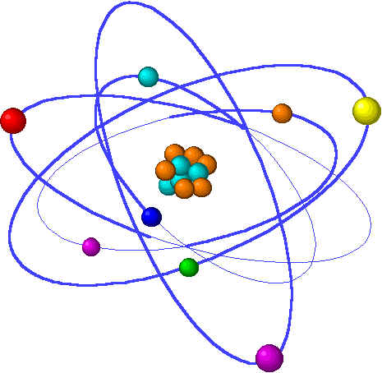

Intermediate 2 Chemistry
Unit 1: Building Blocks

Name
Teacher
Homework | Date Due | Comment
HW 1
HW 2
HW 3
HW 4
HW 5
HW 6
Homework 1

1. Which of the following elements is an alkali metal?

A Aluminium
B Calcium
C Copper
D Sodium

- Lemonade can be made by dissolving sugar, lemon juice and carbon dioxide in water. In lemonade, the solvent is

A water
B sugar
C lemon juice
D carbon dioxide

3 Graph P shows the volume of hydrogen gas collected when 1.0g of magnesium ribbon reacts with excess 2mol l⁻¹ hydrochloric acid.

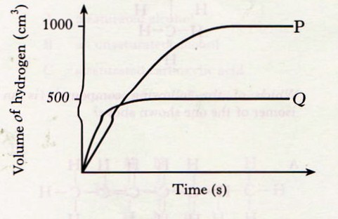

Which of the following samples of magnesium, when reacted with excess 2mol l⁻¹ hydrochloric acid would produce graph Q.

A 0.5g of magnesium ribbon
B 0.5g of magnesium powder
C 1g of magnesium powder
D 2.0g of magnesium ribbon

- Which of the following compounds contains only two elements?

A Magnesium hydroxide
B Magnesium phosphate
C Magnesium sulphite
D Magnesium nitride

- Which of the following gases is a noble gas?

A Nitrogen
B Fluorine
C Oxygen
D Neon

6. When hydrogen chloride gas is dissolved in water a solution containing hydrogen ions and chloride ions is formed.

Which equation correctly shows the state symbols for this change?

A HCl(g) + H₂O(l) → H⁺(aq) +Cl⁻(aq)

B HCl(l) + H₂O(aq) → H⁺(l) +Cl⁻(l)

C HCl(aq) + H₂O(l) → H⁺(aq) +Cl⁻(aq)

D HCl(g) + H₂O(l) → H⁺(l) +Cl⁻(l)

7. The graph below shows the variation of concentration of a reactant with time as a reaction proceeds.

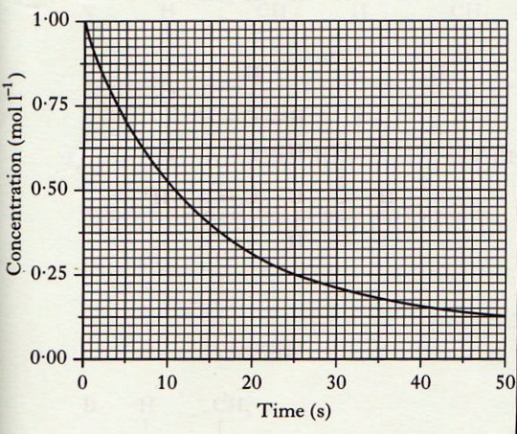

During the first 25s, the average reaction rate, in moll⁻¹s⁻¹, is

A 0.04
B 0.03
C 0.02
D 0.01

- The table shows the times taken for 0.5g of magnesium to react completely with acid under different conditions.
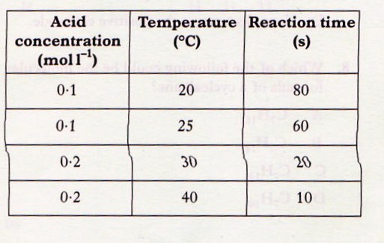

The time for 0.5g of magnesium to react completely with 0.2moll⁻¹ acid at 25ºC will be

A less than 10s
B between 10s and 20s
C between 20s and 60s
D more than 80s

- Which of the following elements is the most recently discovered?
(You may wish to use page 8 of the data booklet to help you)

A Aluminium
B Hydrogen
C Iodine
D Magnesium

- Which of the following gases does NOT exist as diatomic molecules?

A Nitrogen
B Oxygen
C Fluorine
D Neon
End of Homework 1
Homework 2
Part A

- Which of the following elements is the most recently discovered?
(You may wish to use page 8 of the data booklet to help you.)

A Aluminium
B Hydrogen
C Iodine
D Magnesium

- Which of the following gases does NOT exist as diatomic molecules?

A Nitrogen
B Oxygen
C Fluorine
D Neon

- Which of the following elements has similar chemical properties to Argon?

A Fluorine
B Krypton
C Potassium
D Zinc

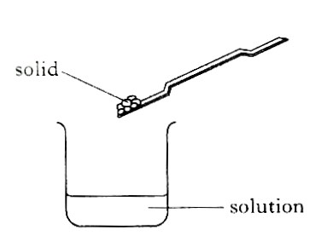
Which of the following would NOT be evidence of a chemical reaction when the solid is added to the solution?

A A colour change
B A gas being given off
C The temperature rising
D The solid disappearing

- Which line in the table shows the approximate percentage composition of air?

 | Nitrogen | Oxygen | Carbon  Dioxide | Noble  gases
A | 78 | 21 | 0.03 | 1
B | 21 | 78 | 1 | 0.03
C | 1 | 21 | 78 | 0.03
D | 0.03 | 78 | 1 | 21

Part B

- a) Zinc reacts with dilute hydrochloric acid producing hydrogen gas.
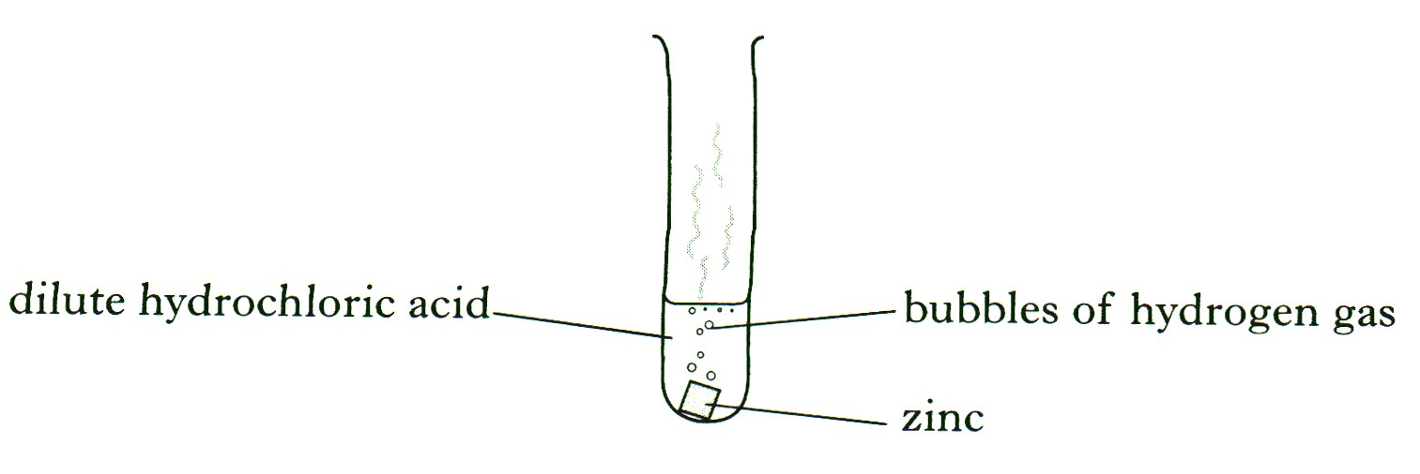

(i) State the test for hydrogen gas.

1mark

(ii) During the experiment, the test tube becomes warm.
What term is used to describe a reaction which gives out heat?

1mark

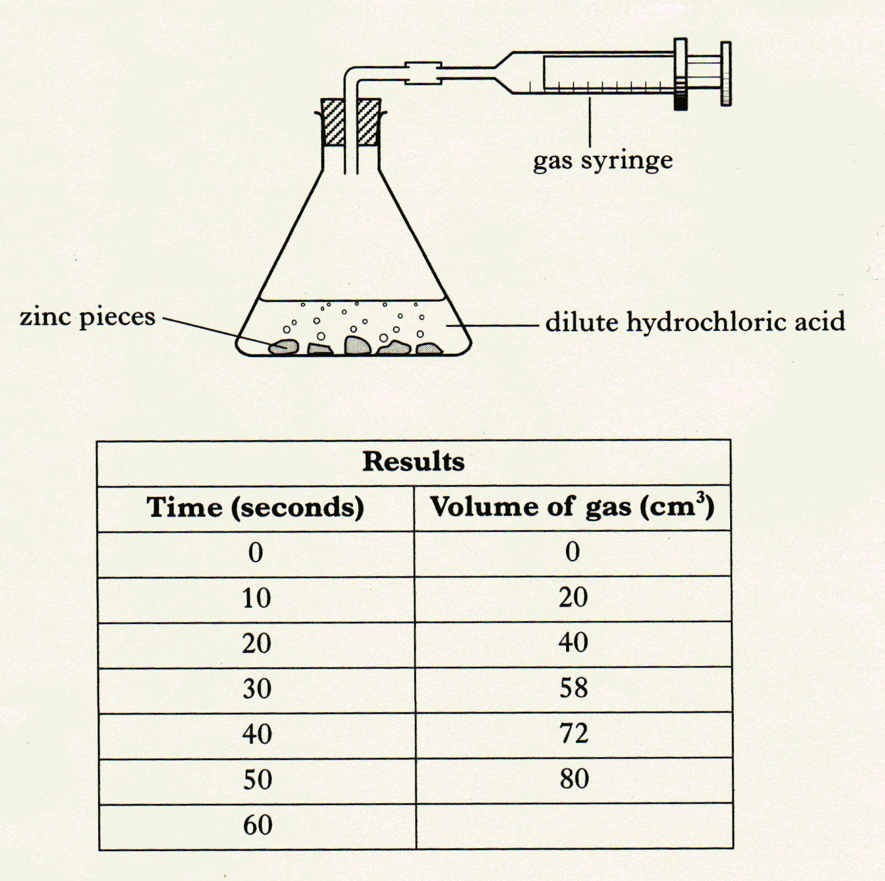
b) The rate of reaction between zinc and dilute hydrochloric acid can be followed by measuring the volume of gas given off during the reaction.

(i) Plot a line graph of the results of the reaction. 2marks

(ii) Predict the volume of gas (cm³) which would have been given off after 60seconds.

1mark

c) Calculate the average rate in cm³s⁻¹ at which gas is given off during the first 40seconds of the reaction.

1mark

d) Why would increasing the concentration of the acid increase the rate of the reaction?

1mark
(7)

- The alkali metals, the halogens and the noble gases are the names of groups of elements in the Periodic Table. Copy and complete the table by circling a word in each box to give correct information about each group.
(Two pieces of correct information have already been circled.) 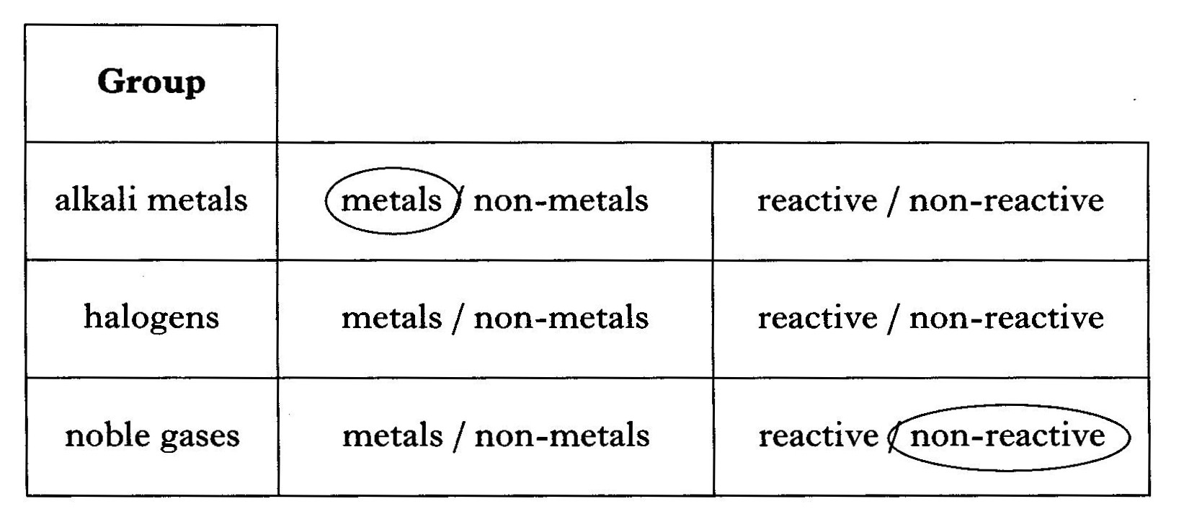
2marks (2)

- In the Unit 1 PPA, “Effect of concentration on reaction rate”, the reaction between sodium persulphate and potassium iodide solutions is studied.

Set up for experiment 1
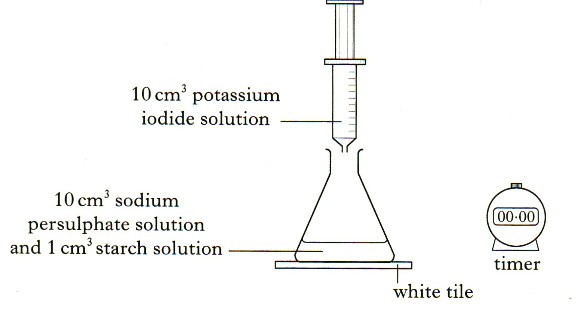
Results

Experiment | 1 | 2 | 3 | 4
Volume of sodium persulphate solution (cm³) | 10 | 8 | 6 | 4
Volume of water (cm³) | 0
Reaction time (min) | 2.1 | 2.7 | 3.5 | 5.6

a) Complete the table to show the volumes of water used in experiments
2,3 and 4. 1mark
b) How would you know when to stop the timer in each experiment? 1mark

c) Why are volumes of sodium persulphate solution less than 4 cm³ not used? 1mark (3)

9) Liquid oils can be converted into hardened fats using a slid catalyst. The catalyst used is the transition metal, nickel. What type of catalyst is nickel? 1mark (1)

- Dinitrogen monoxide can be used to boost the performance of racing car engines. When dinitrogen monoxide decomposes it forms a mixture of nitrogen and oxygen. The reaction is exothermic.

2N₂O(g) → 2N₂(g) +O₂(g)

What is meant by an exothermic reaction? 1mark(1)

- Sodium thiosulphate (Na2S2O3) reacts with hydrochloric acid as shown.

(Na⁺)₂S₂O₃²⁻(aq) + 2H⁺Cl⁻(aq) → 2Na⁺Cl⁻(aq) +S(s) + SO₂(g) + H₂O(l)

This reaction is used in a PPA to study the effect of temperature on reaction rate. The rate is determined from the time taken to produce a certain amount of sulphur.
How would you decide when to stop timing? 1mark
End of Homework 2
Homework 3

1. The mass number of the atom ²³Na is
¹¹
A 11
B 12
C 23
D 34

- The table shows information about some atoms.
Atom | Atomic number | Mass Number
W | 16 | 34
X | 18 | 36
Y | 18 | 40
Z | 20 | 40

Which two atoms are isotopes of the same element?

A W and X
B X and Y
C W and Y
D Y and Z

- Which of the following pairs of elements combine to form an ionic compound?

A Lead and fluorine
B Sulphur and oxygen
C Carbon and nitrogen
D Phosphorus and chlorine

- Which of the following particles contains a different number of electrons from the others?
(You may wish to use page 1 of the data booklet to help you.)

A Cl⁻
B S²⁻
C Ar
D Na⁺

- 2,8,8 is the electron arrangement for an atom of an element belonging to the

A halogens
B noble gases
C alkali metals
D transition metals

- Different atoms of the same element have identical

A nuclei
B mass numbers
C numbers of neutrons
D numbers of protons

- Which of the following compounds exist as diatomic molecules?

A Carbon monoxide
B Carbon tetrachloride
C Nitrogen trihydride
D Sulphur dioxide

- A substance, X , has a melting point of 996⁰C and a boiling point of 1704ºC. It only conducts electricity when molten or when dissolved in water. The structure of X is likely to be

A ionic
B metallic
C covalent network
D covalent molecular

- Metallic bonds are due to

A pairs of electrons being shared equally between atoms
B pairs of electrons being shared unequally between atoms
C the attraction of oppositely charged ions for each other
D the attraction of oppositely charged ions for delocalised electrons

- During the electrolysis of silver(I)nitrate solution, silver ions, Ag⁺(aq),

A gain electrons at the negative electrode
B lose electrons at the negative electrode
C gain electrons at the positive electrode
D lose electrons at the positive electrode.
End of Homework 3
Homework 4

Part A

- Different isotopes of the same element have identical

A nuclei
B mass numbers
C atomic numbers
D numbers of neutrons

- A metal X reacts with oxygen to form an oxide, X₂O₃.
During the reaction each atom of metal X

A gains two electrons
B gains three electrons
C loses two electrons
D loses three electrons

- Which of the following elements conducts electricity?

A Bromine
B Mercury
C Oxygen
D Sulphur

- An atom has atomic number 26 and mass number 56. The number of electrons in the atom is

A 26
B 30
C 56
D 82

- During the electrolysis of copper(II) chloride solution, the reaction taking place at the positive electrode is

A Cu²⁺ (aq) + 2e⁻ → Cu(s)

B Cu(s) → Cu²⁺ (aq) + 2e⁻

C 2Cl⁻(aq) → Cl₂(g) +2e⁻

D Cl₂(g) +2e⁻ → 2Cl⁻(aq)

- Complete the table for the particle shown below.

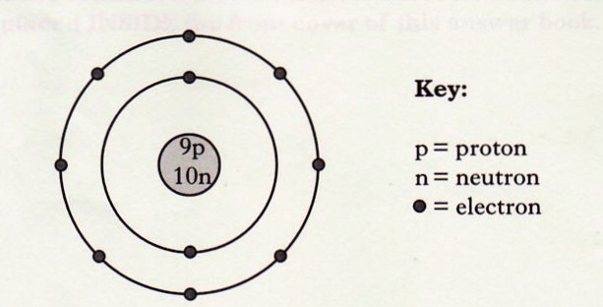

Atomic  Number | Symbol for the  Element | Mass number | Overall charge  Of the particle

2marks (2)

- The nuclide notation for an isotope of hydrogen is ¹H.
¹
a) An isotope of bromine has atomic number 35 and mass number 81.
(i) Complete the nuclide notation for this isotope of bromine.

Br 1mark

(ii) How many neutrons are there in this isotope?

1mark

b) Bromine has two isotopes. One has a mass number of 81 and the other a mass number of 79.
The relative atomic mass of bromine is 80.
What does this tell you about the percentage of each isotope in bromine?

1mark (3)

- Hydrogen reacts with chlorine to form hydrogen chloride.

a) Draw a diagram to show how the outer electrons are shared in a molecule of hydrogen chloride.

1mark

b) Chlorine has a greater attraction than hydrogen for the bonded electrons in a hydrogen chloride molecule.
What term is used to describe this type of covalent bond?

1mark (2)

9) a) The explosive, TNT, is a covalent compound with a low melting point.
Which type of covalent structure does TNT have?

1mark

b) The equation shows the reaction when the compound, TNT, explodes.

TNT + oxygen → carbon dioxide + nitrogen + water

Using the equation, name the elements that must be present in the TNT.

1mark (2)

- Carborundum and silica are examples of covalent network compounds.

- In carborundum, the lattice contains equal numbers of silicon and carbon atoms.

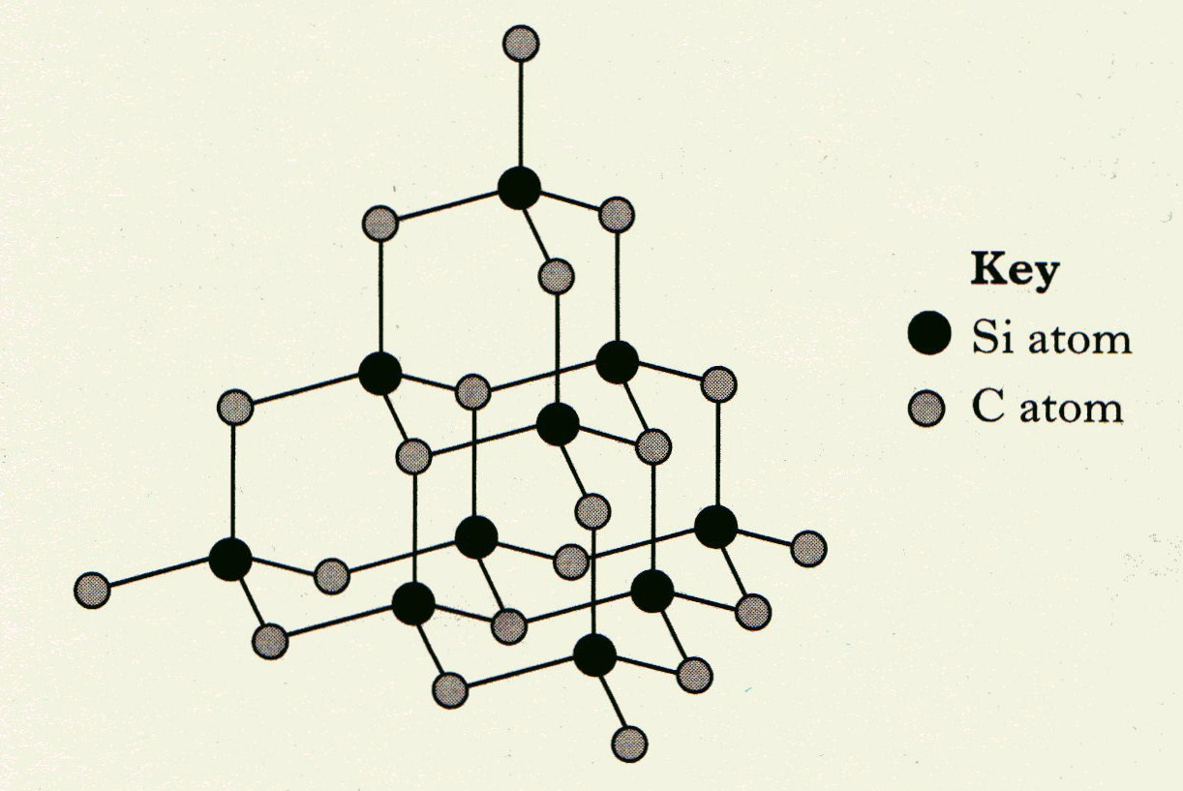

Write the formula for carborundum 1mark

10 b) Part of the silica lattice is shown below.

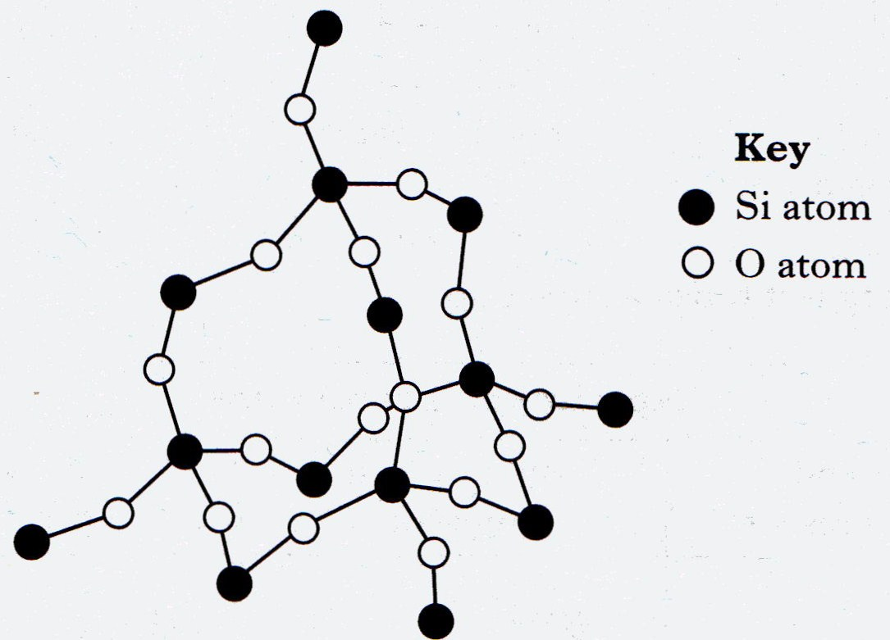

(i) Why does silica not conduct electricity?

1mark

(ii) Why does silica have a high melting point?

1mark (3)

11)
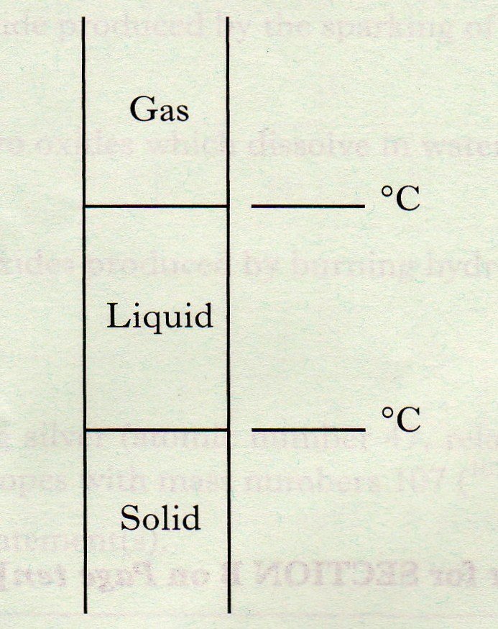

a) Using information from the data booklet, mark on your diagram the melting and boiling point of barium chloride. 1mark

b) In what state is barium chloride at 900 ⁰C?

1mark
(2)

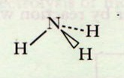
- The diagram represents the structure of a molecule of ammonia.

a) Why are the bonds between the nitrogen and the hydrogen in an ammonia molecule described as polar covalent?

1mark (1)

End of Homework 4
Homework 5

- In a reaction, calcium silicate is decomposed to calcium oxide and silicon dioxide.

CaSiO₃(s) → CaO(s) + SiO₂(s)

Which of the following statements about the reaction is correct?

A The number of moles of products is less than the number of moles of reactant.
B The number of moles of products equals the number of moles of reactant.
C The mass of the products equals the mass of the reactant.
D The mass of the products is less than the mass of the reactant.

- What is the correct formula for aluminium sulphate?

A AlSO₄
B Al(SO₄)₃
C Al₂(SO₄)₃
D Al₃(SO₄)₃

- Glucose has the molecular formula C₆H₁₂0₆. How many moles are contained in 18g of glucose?

A 0.01
B 0.1
C 1
D 10

- 0.2mol of gas has a mass of 12.8g. Which of the following could be the molecular formula for the gas?

A SO₂
B CO
C CO₂
D NH₃

- The formula for potassium sulphate is

A P₂SO₃
B K₂SO₄
C P₂SO₄
D K₂S

- The formula for magnesium sulphite is

A MgS
B MgSO₃
C MgSO₄
D MgS₂O₃

- What is the charge on the chromium ion in CrCl₃?

A 1+
B 1-
C 3+
D 3-

- What is the relative formula mass of ammonium sulphate, (NH₄)₂SO₄?

A 70
B 118
C 132
D 228

9. How many moles are present in 1.7g of ammonia, NH₃?

A 0.1
B 1.0
C 1.7
D 17

10. What is the name of the compound with the formula Ag₂O?

A Silver(I) oxide
B Silver(II) oxide
C Silver(III) oxide
D Silver(IV) oxide

End of Homework 5
Homework 6

- Which molecule has the smallest gram formula mass?

A Methane
B Nitrogen
C Carbon monoxide
D carbon dioxide

- What is the charge on the iron ion in Fe₂O₃

A 2+
B 2-
C 3+
D 3-

- What is the relative formula mass of ammonium phosphate, (NH₄)₃PO₄

A 113
B 121
C 149
D 242

- The formula for calcium sulphate is

A Ca₂S
B CaSO₄
C Ca₂SO₄
D CaS₂O₄

5) Fructose has the molecular formula C₆H₁₂0₆. How many moles are contained in 18g of glucose?

A 0.01
B 0.1
C 1
D 10

6) A new air bag is being developed for use in cars. In the reaction, butane reacts with an oxide of nitrogen.

C₄H₁₀ + N₂O → CO₂ +H₂O + N₂

Balance this equation 1mark

- Dinitrogen monoxide can be used to boost the performance of racing car engines. When dinitrogen monoxide decomposes it forms a mixture of nitrogen and oxygen. The reaction is exothermic.

2N₂0(g) → 2N₂(g) + O₂(g)

How many moles of oxygen will be produced when four moles of dinitrogen monoxide are decomposed?

1mark

- The equation for the preparation of magnesium sulphate from magnesium as carried out in Unit 3 PPA1- preparation of a salt is shown below.

Mg(s) + H₂SO₄(aq) → MgSO₄(aq) +H₂(g)

Calculate the mass of magnesium sulphate produced when 4.9g of magnesium reacts completely with dilute sulphuric acid.

2 marks

9) Urea is a chemical which is present in urine. Urea has the formula H₂NCONH₂. An adult male, on average, excretes 30g of urea each day.
How many moles are there in 30g of urea?

1 mark

10) Lawn fertiliser can contain iron(II) sulphate to kill moss in the lawn.
Iron(II) sulphate can be made by reacting iron(II) oxide with dilute sulphuric acid.

FeO(s) + H₂SO₄(aq) → FeSO₄(aq) + H₂O(l)

What mass of iron(II) sulphate in kg can be made from 144kg of iron(II) oxide?

2marks

- Sodium carbonate reacts with dilute hydrochloric acid.
Write the formula for sodium carbonate.

1 mark

- Plants release ethene gas. A build up of ethene in florists shops will cause flowers to wither quickly. Florists can use a solid titanium dioxide catalyst to break down ethene gas to make flowers last longer.

In the reaction, ethene reacts with the oxygen of the air to produce carbon dioxide and water.

Balance the equation for this reaction.

C₂H₄(g) + O₂(g) → CO₂(g) + H₂O(l) 1 mark

- Ammonia gas can be produced in the lab by heating ammonium chloride with sodium hydroxide.
Calculate the mass in grams of ammonia produced by heating 10g of ammonium chloride.

NH₄Cl + NaOH → NaCl + H₂O + NH₃

2 marks

- Natural gas contains unwanted sulphur compounds. Burning sulphur compounds releases sulphur dioxide into the atmosphere. The sulphur can be removed from compounds found in natural gas by reacting the compounds with hydrogen gas.

The equation for the removal of sulphur from one compound is shown.

CH₃SH + H₂ → C₂H₆ + H₂S

Balance this equation 1 mark

- In the Unit 1 PPA, “Effect of concentration on reaction rate”, the reaction between sodium persulphate and potassium iodide solutions is studied.

The formula for the persulphate ion is S₂O₈²⁻ .
Write the formula for sodium persulphate.

1 mark

16) What mass of copper(II) sulphate (gram formula mass = 159.5g) is required to make 400cm³ of 0.5 moll⁻¹ copper(II) sulphate solution?

2 marks
End of Homework 6

