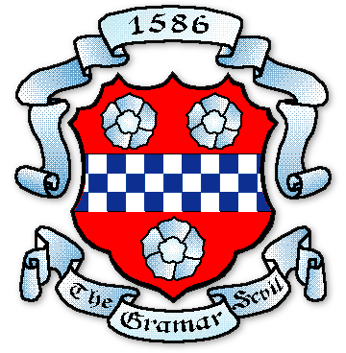
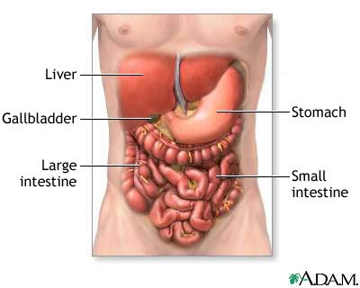


PAISLEY GRAMMAR SCHOOL

BIOLOGY DEPARTMENT

INTERMEDIATE 2 BIOLOGY
HOMEWORK

Unit 3: Animal Physiology

HW 1: Nutrition
HW 2: Section C Questions on Nutrition
HW 3: Regulation of the Internal Environment
HW 4: Section C Questions on Regulation of the Internal Environment
HW 5: Circulation and Gas Exchange
HW 6: Section C Questions on Circulation and Gas Exchange
HW 7: Blood
HW 8: Section C Questions on Blood
HW 9: The Brain and Nervous System
HW 10: Section C Questions on The Brain and Nervous System

Sub-Unit 3A: Mammalian Nutrition
Homework 1: Nutrition

Q1. A food sample was tested to find which food groups were present. Both the Benedict’s test and the Biuret test were positive.

- What colour indicates a positive result with the Benedict’s test?
1

- Which food group was indicated by the Biuret result?
1

(b) Complete boxes 1 and 2 in the following diagram which shows information about the structures of three food groups.

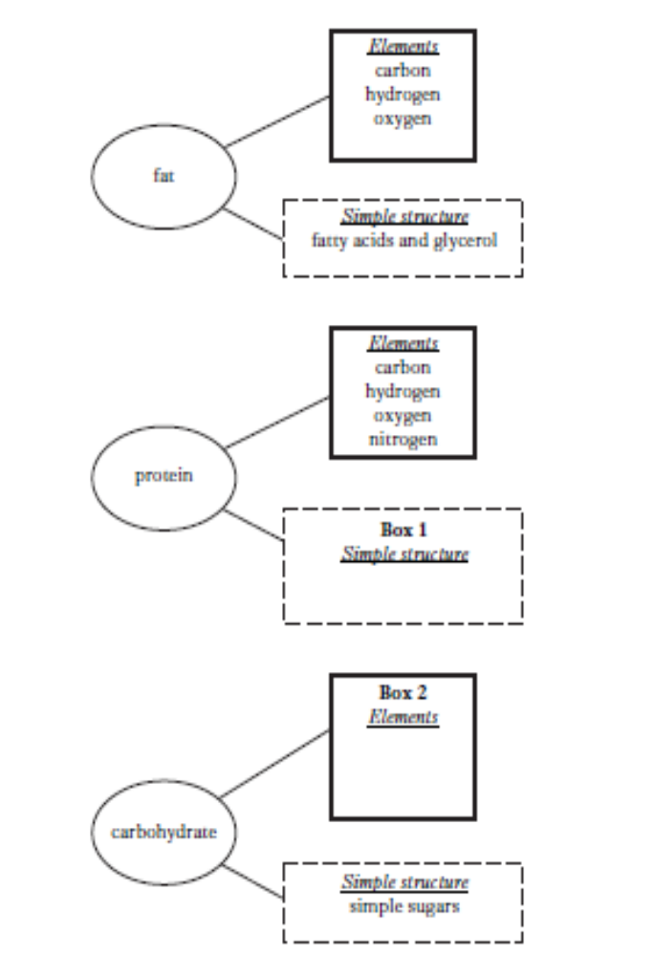
2

(c) The graph below shows the results of an experiment into the activity of a stomach enzyme at various pH levels.
1

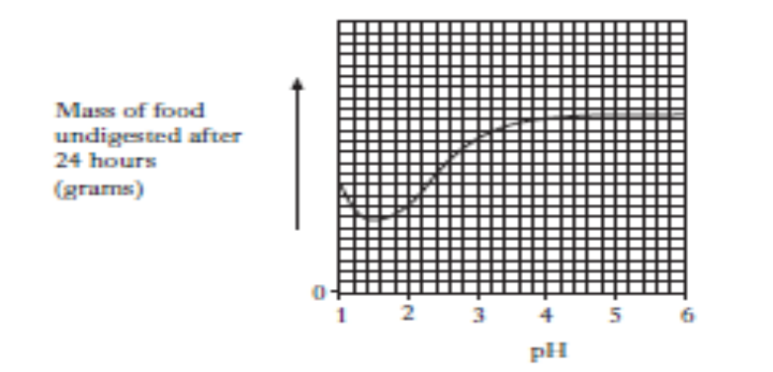
1
(i) Name a stomach enzyme.
1
(ii) From the graph, what is the optimum pH of this enzyme?

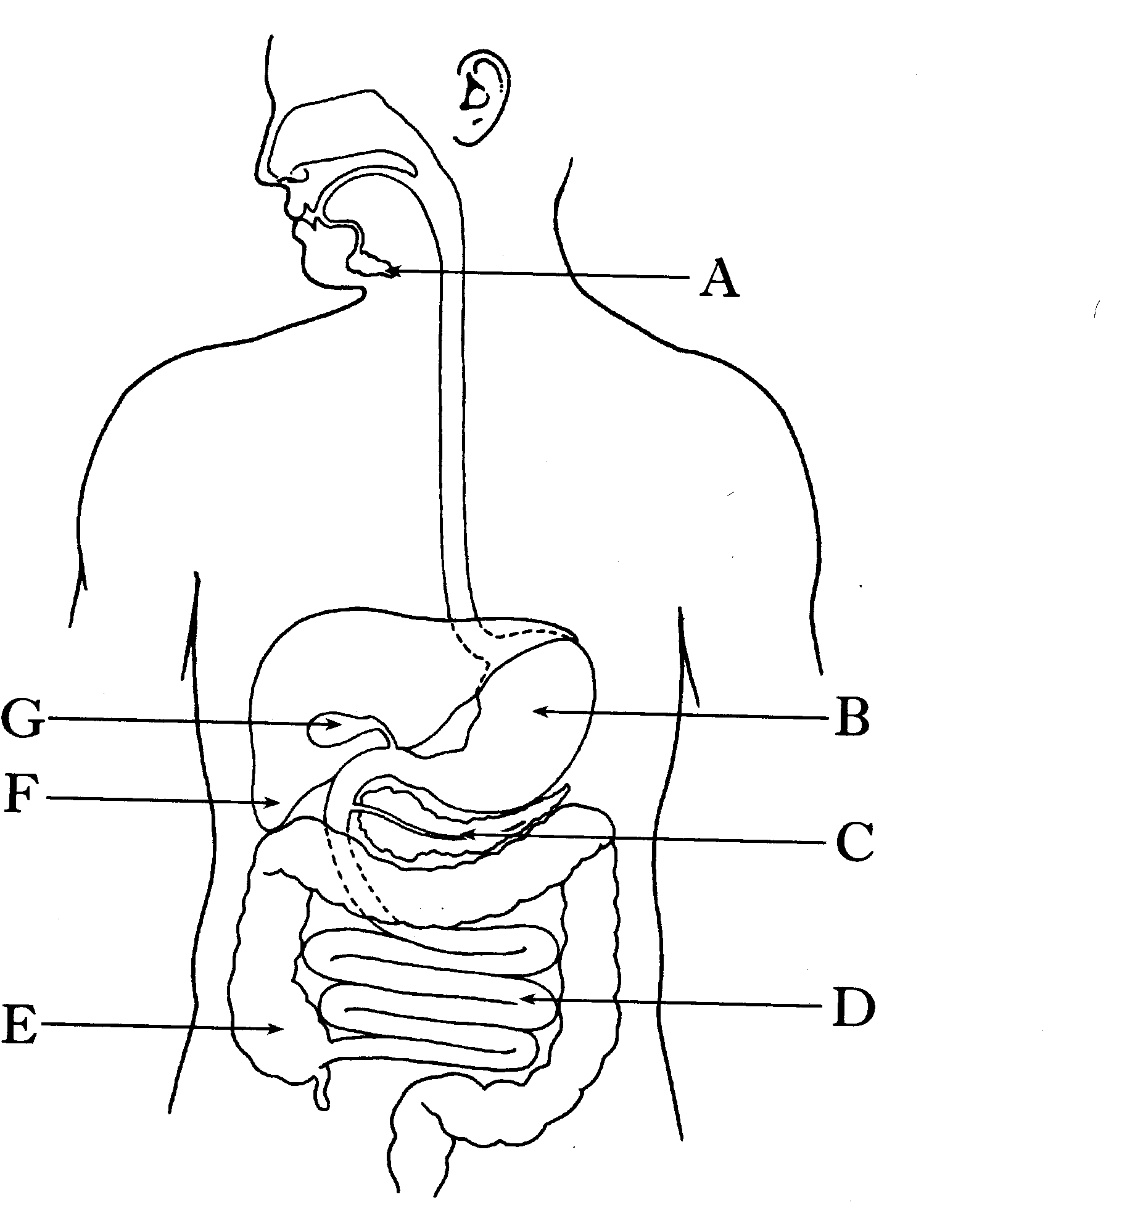
Q2. The diagram below shows the human alimentary canal.
1
1
1
1

(a) Name the following labelled parts.
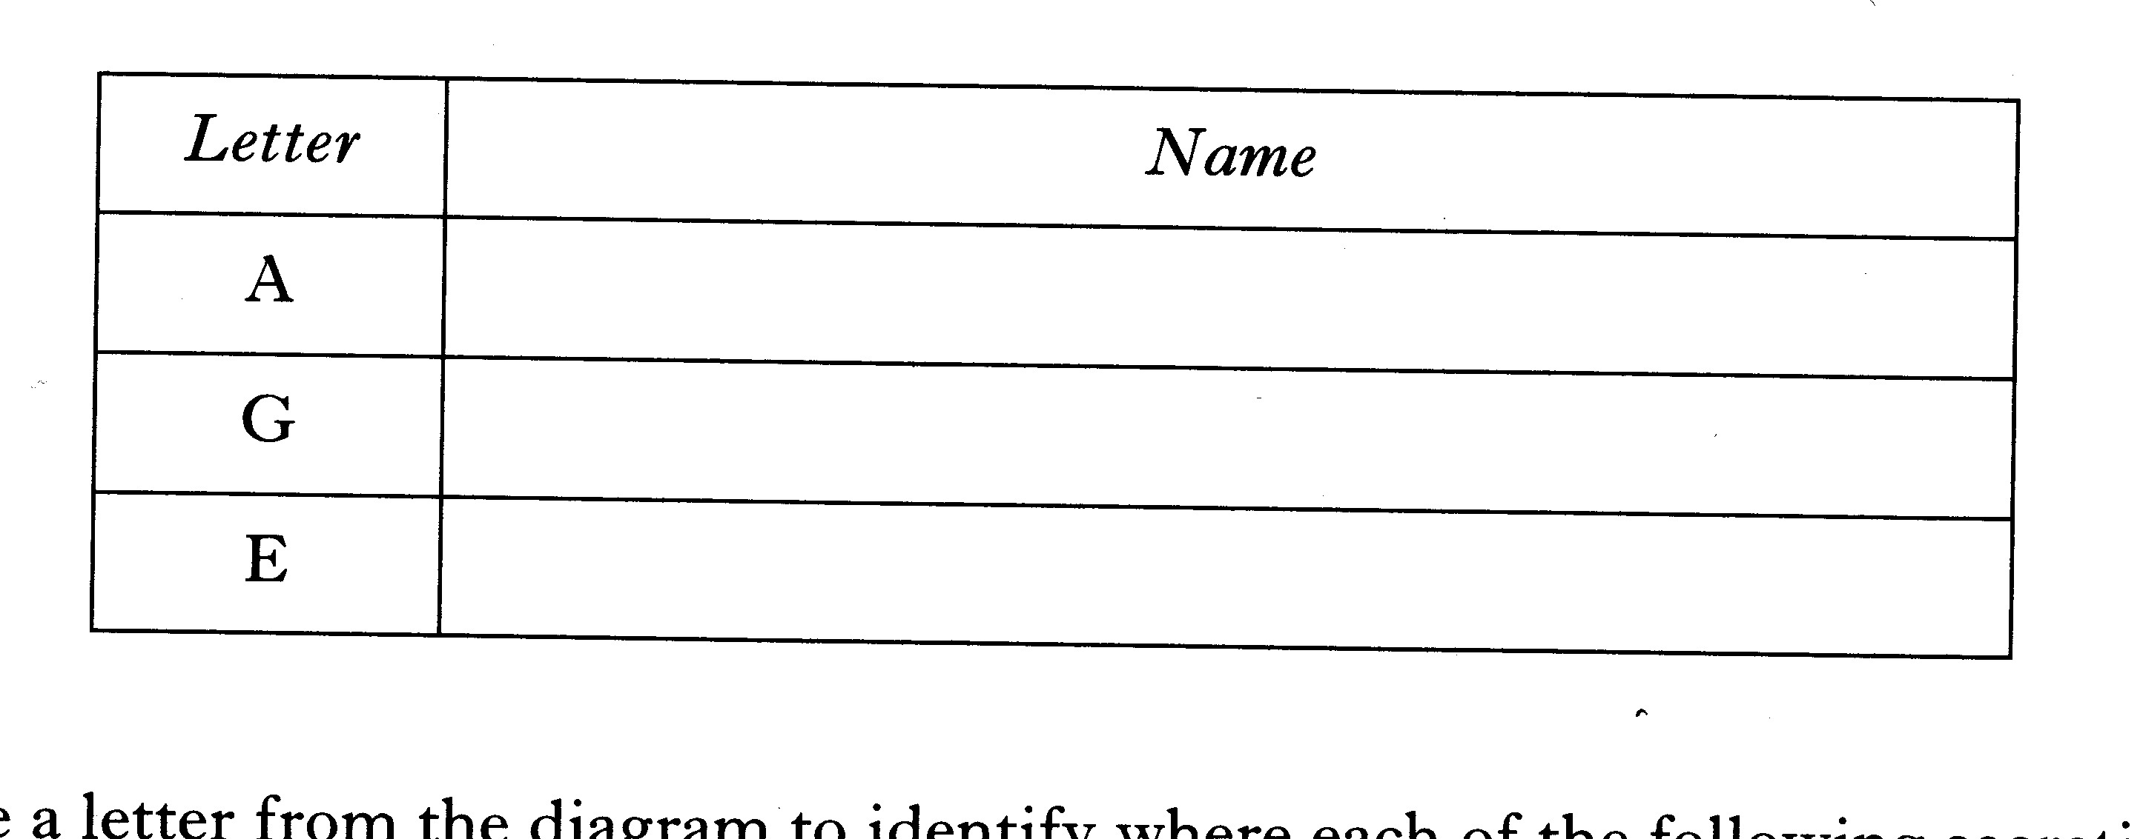
2
(b) Use a letter from the diagram to identify where each of the following secretions are produced.

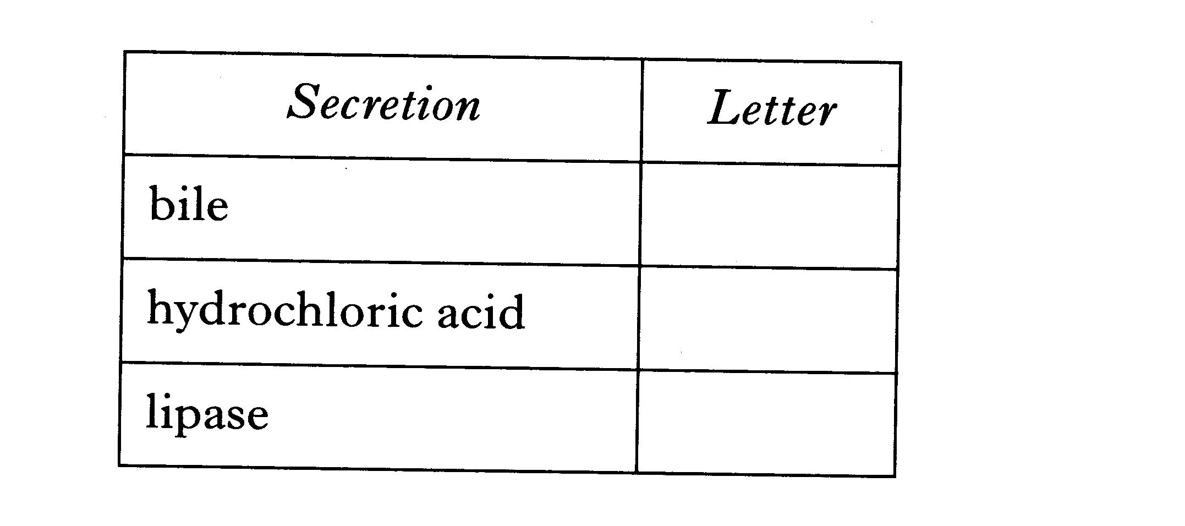
3

(c) Excess glucose in the diet is converted into an in soluble compound which is stored in the liver.
1
Name this compound.

Q3. The diagram below shows a single villus from the small intestine.
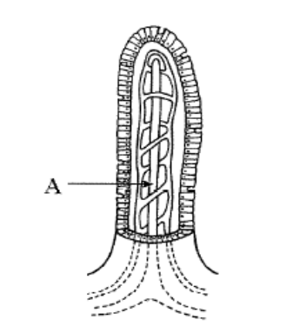
1
(a) Name the part labelled A.

(b) Absorption of glucose takes place in the small intestine.

(i) Name the part of the villus into which glucose passes.
1

(ii) Name the organ to which the glucose is transported after leaving the small intestine.
1

(iii) Describe one possible use of glucose in the body.
1

(c) The stomach is a major organ of the alimentary canal.

(i) Name two types of secretory cell found in the stomach.
2

(ii) Describe the function of the muscles in the stomach wall.
2

Q4. The diagram below shows the small intestine with associated organs and blood vessels.

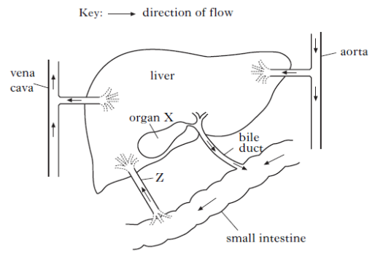

(i) Blood vessel Z carries amino acids to the liver.

(A) Name blood vessel Z
1
1
(B) Describe what happens to excess amino acids in the liver.

1
(ii) (A) Name organ X.

(B) Describe the function of the bile that is released from organ X.
1

(b) Complete the table below which shows the substrate and product of two enzymes found in the small intestine.

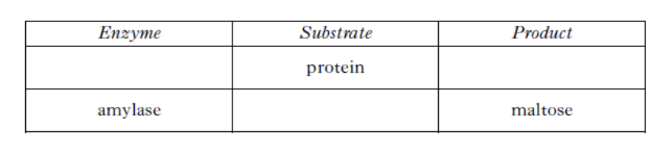
2
1

END OF HOMEWORK 1

Sub-Unit 3A: Mammalian Nutrition
Homework 2: Section C questions on Nutrition

Q1. The diagram below shows a stage in the movement of food down the oesophagus.

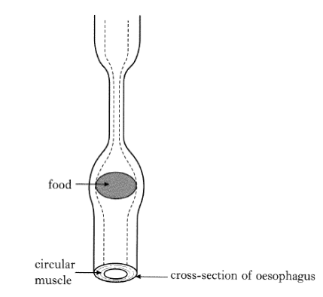

Name and describe the movement of the food through the oesophagus.
5

Q2. Describe the role of the small intestine in the digestion and absorption of food.
5

END OF HOMEWORK 2

Sub-Unit 3B: Control of The Internal Environment
Homework 3: Control of the internal environment

Q1. The diagram below shows the human urinary system with its blood supply.

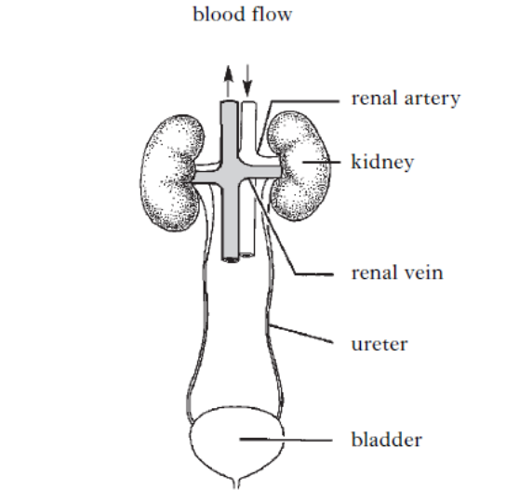

(a) An investigation was carried out to measure the concentration of three substances in samples of blood and urine.

The table below shows the results of this investigation.

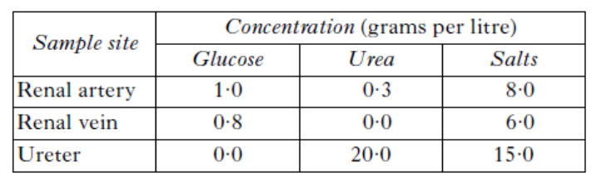
1
(i) Calculate the percentage of glucose remaining in the blood after it passes through the kidney.
1
(ii) Explain how the data in the table supports the statement that urea is a waste product.
1
(iii) Name one substance, not shown in the table, which is present in urine.

(b) Name the two processes in the kidney which cause the differences
in salt concentration between blood and urine.
1
Process 1_______________________________
1
Process 2_______________________________

(c) Freshwater bony fish use their kidneys to overcome a water balance problem. Describe this problem and one method used by the kidneys to overcome it.
1

Q2. (a) The diagram below shows part of the human urinary system.

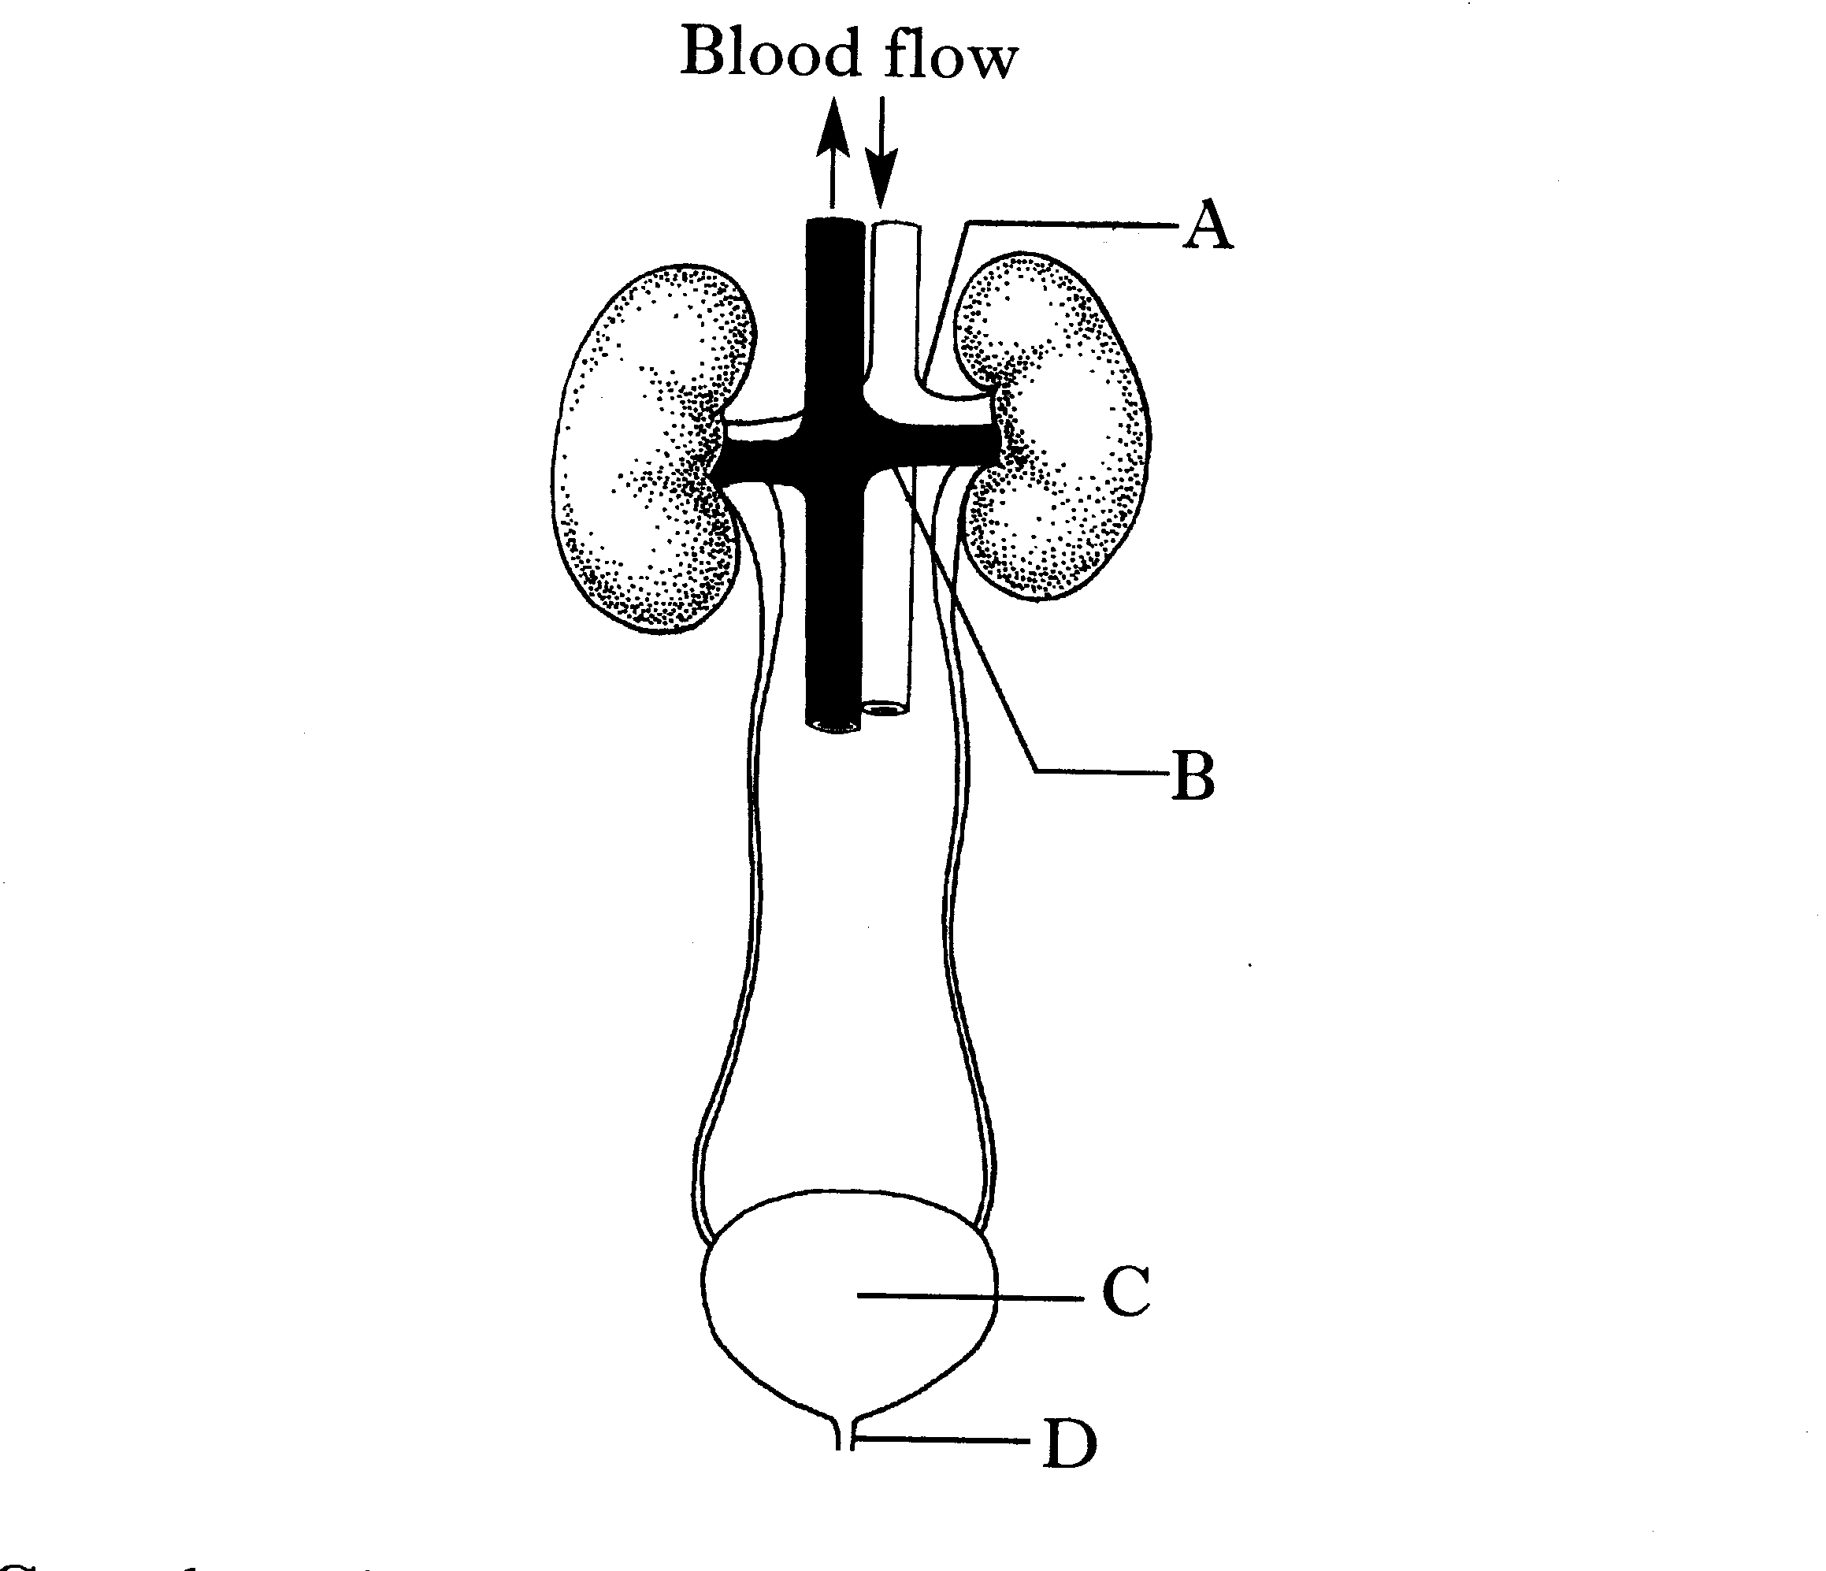
(i) Complete the table below to name the labelled parts and give their functions.
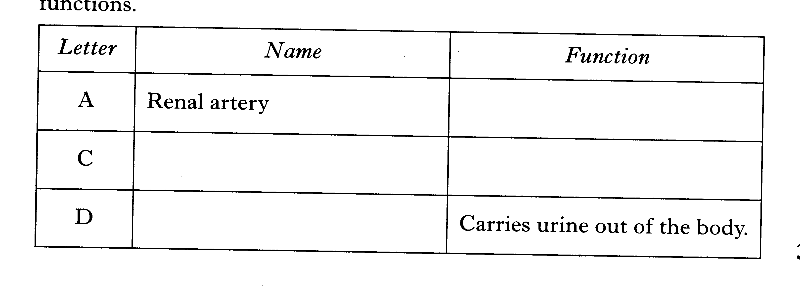
3
(ii) Give one difference between the composition of blood in vessels A and B.
1

(b) Glucose is present in the blood entering the kidney.
1
Explain why glucose does not normally appear in the urine.

(c) (i) Name the hormone which is produced in response to a reduction in water concentration of the blood.
1

(ii) State the effect this hormone has on the kidney tubules.
1

Q3. (a) A freshwater fish is hypertonic to its environment.

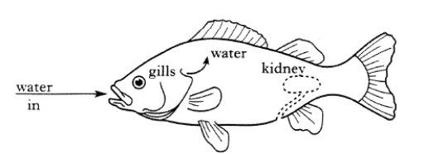

Pick one option in each set of statements to make the sentences below correct.

The gills of this fish take in/give out salts.

The kidneys produce a large/small volume of dilute/concentrated urine.
2

(b) (i) Name the hormone that acts on the kidney to maintain water balance in humans.
1

(ii) Name the part of the kidney nephron on which the hormone has its effect.
1

(iii) When the concentration of water in the blood increases, the hormone acts to return the water concentration to normal.
1
What term is used to describe this mechanism?

END OF HOMEWORK 3
Sub-Unit 3B: Control of The Internal Environment
Homework 4: Section C questions on Control of Internal Environment

Q1. Freshwater bony fish have a water balance problem. State the water balance problem and describe how these fish overcome the problem.
5

Q2. Urine production occurs in the kidney. The diagram below shows the structure of a nephron and its blood supply.
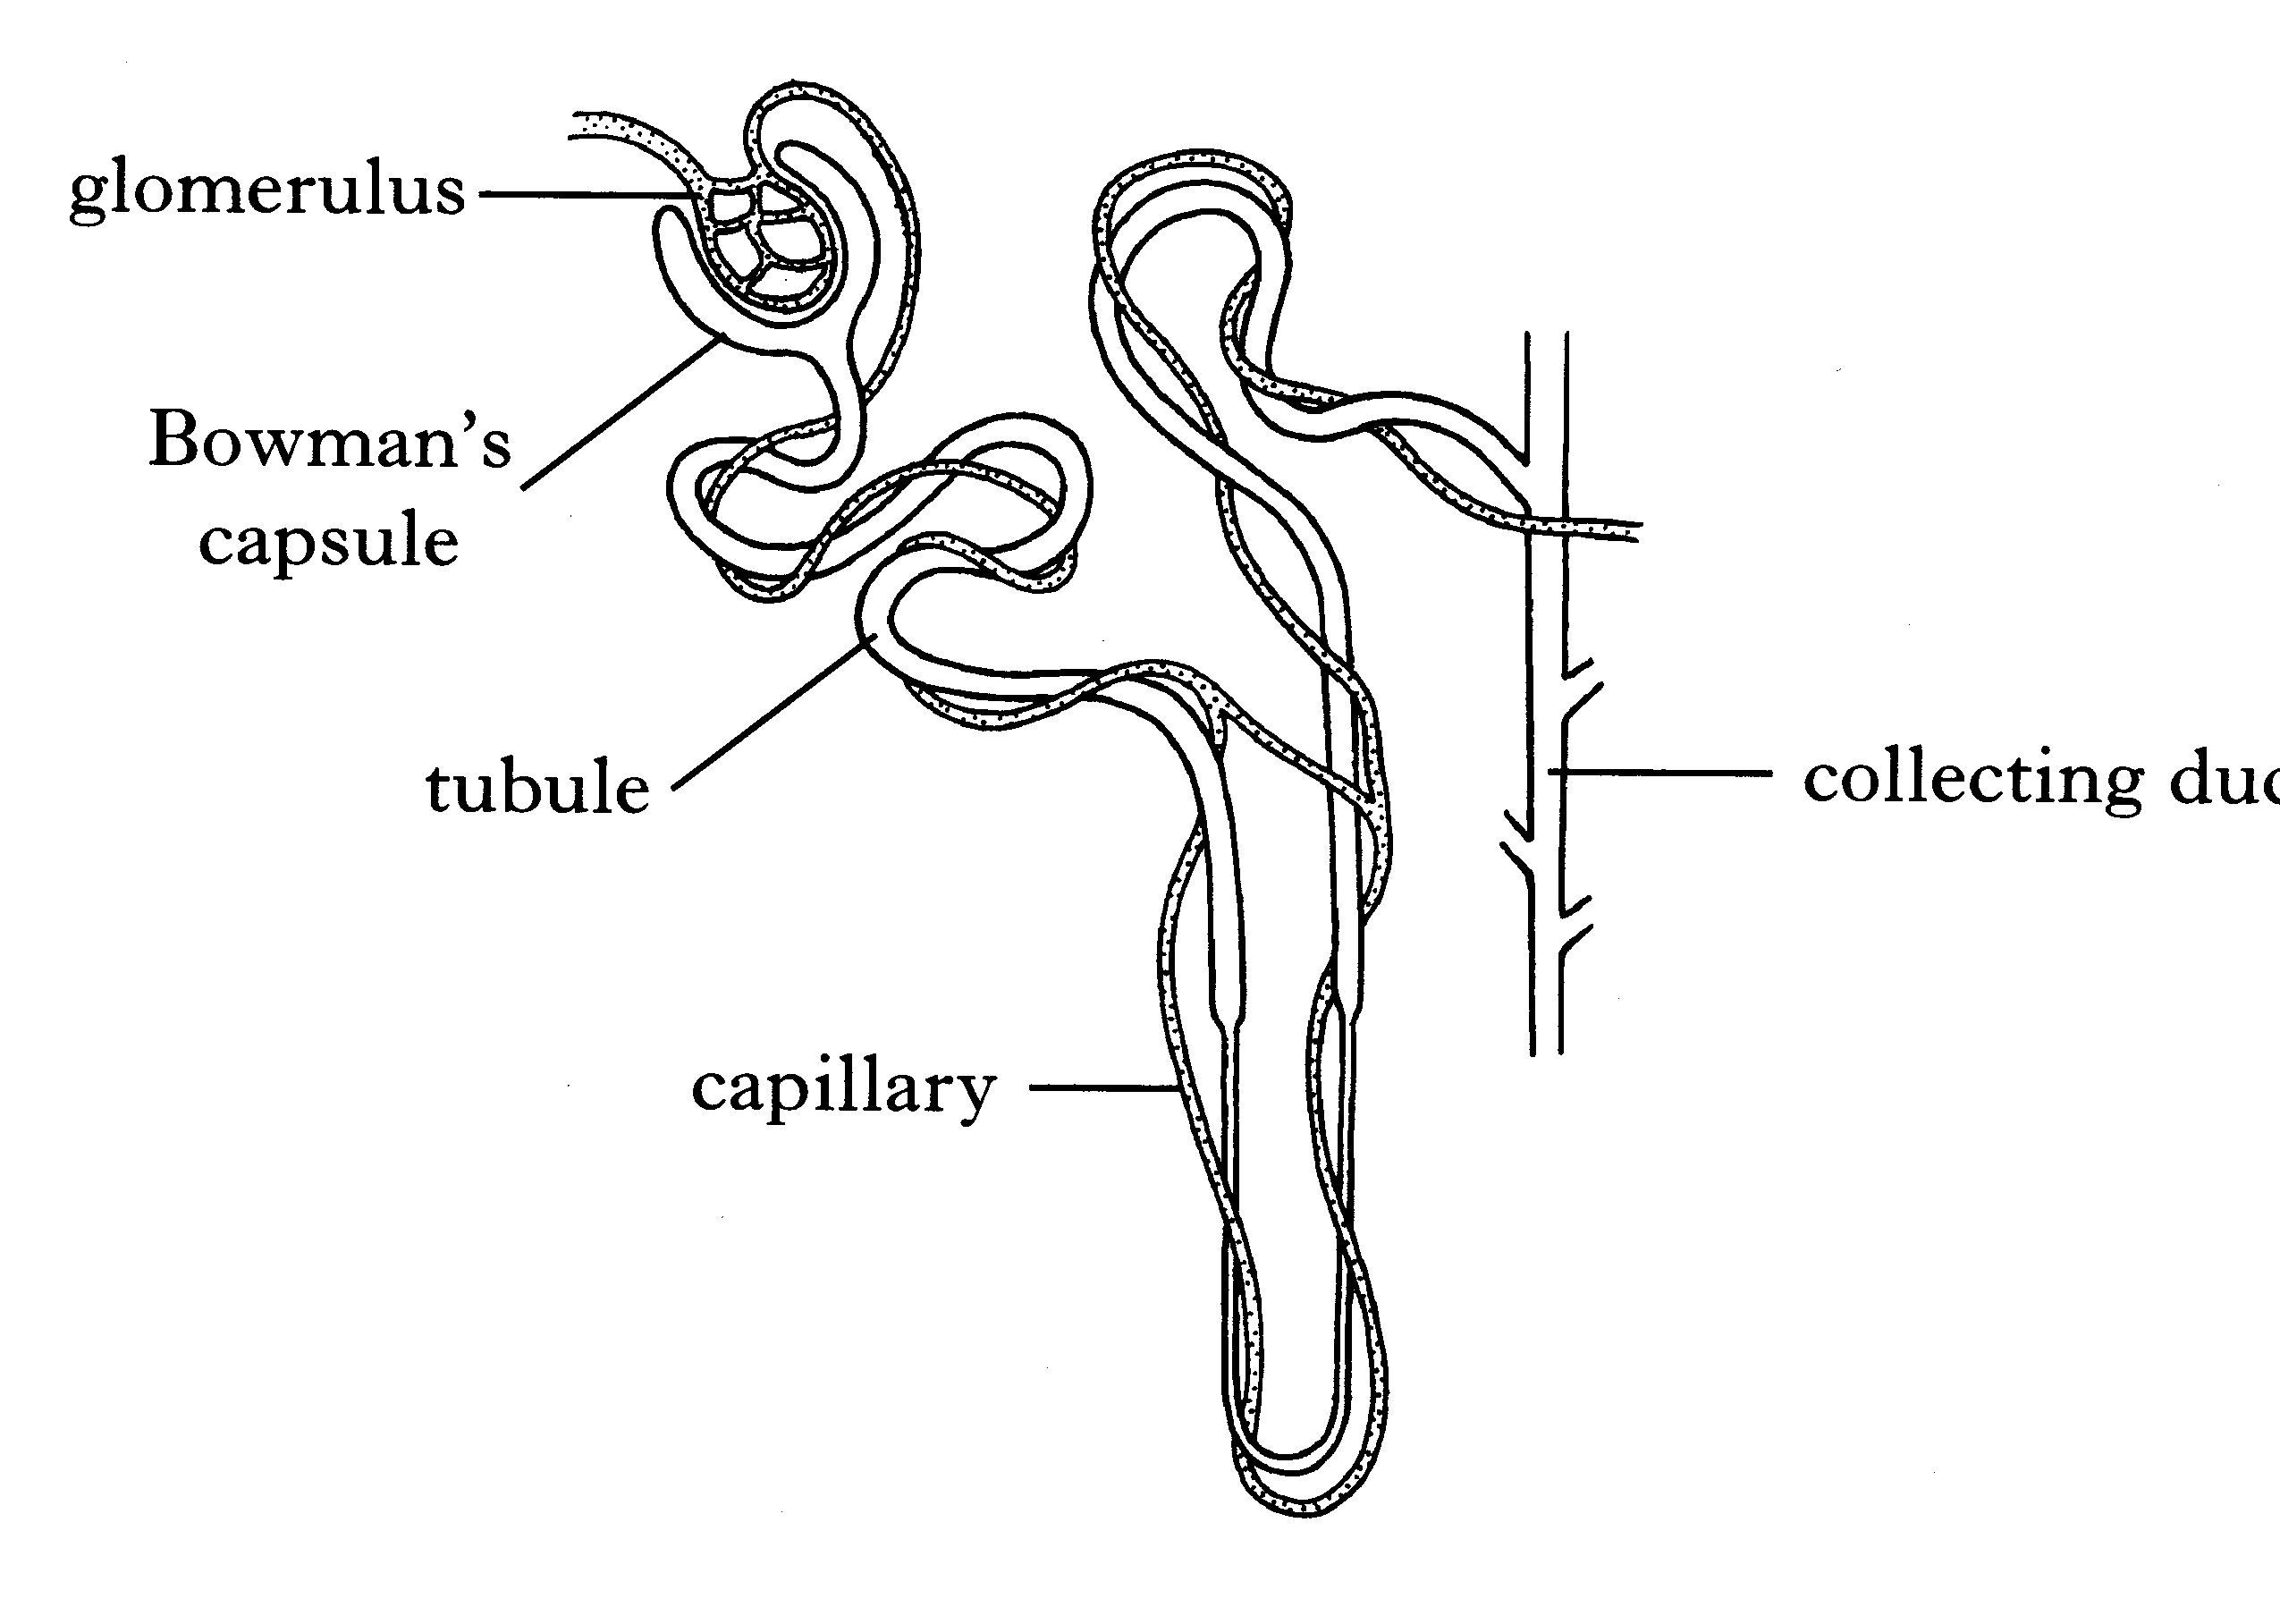
Describe how the nephron produces urine. There is no need to mention the role of ADH.
5

Q3. Describe the role of the hypothalamus and ADH in the control of the water concentration of the blood.
5

END OF HOMEWORK 4

Sub-Unit 3C: Circulation and Gas Exchange
Homework 5: Circulation and Gas Exchange

Q1. The diagram below shows a section through the heart.

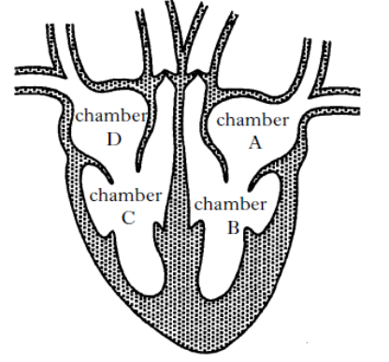
(a) (i) Blood follows a pathway through the heart and lungs
from the vena cava to the aorta. Use letters from the diagram to complete the following flow
chart to show the correct pathway.
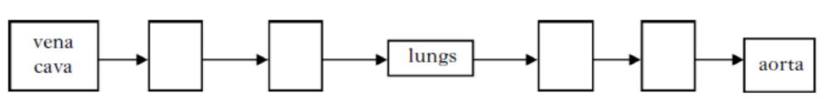
1

(ii) State the letter of a chamber of the heart which contains oxygenated blood.
1

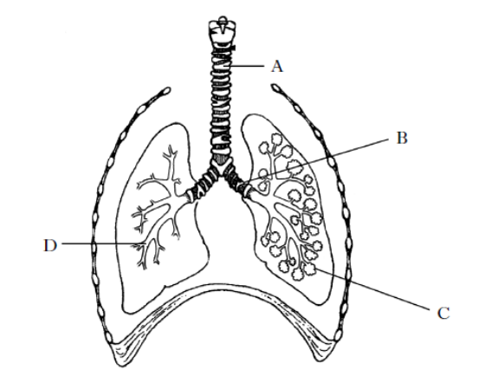
Q2. The diagram below shows the human breathing system.

(a) Complete the table below to identify the labelled structures.
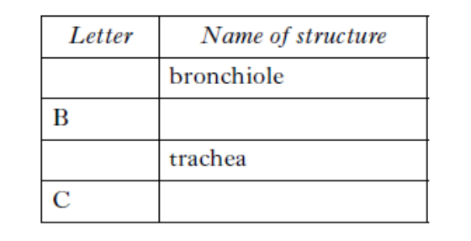

2

(b) A person breathed normally, took deep breaths, then returned to normal breathing.
The volume of air in the lungs was measured and the results are shown in the graph below.

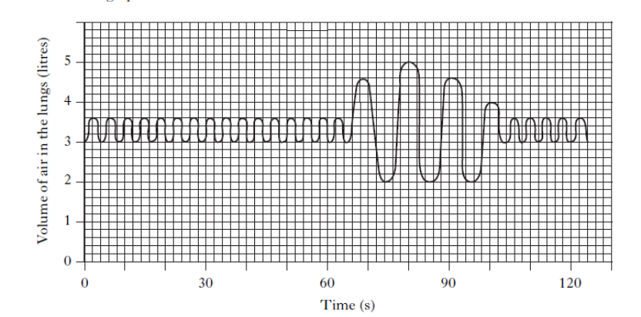
1
(i) What was the normal breathing rate for this person?
1
(ii) What was the highest volume of air inhaled in a single breath?

Q3. The diagram below shows part of the human circulatory system.
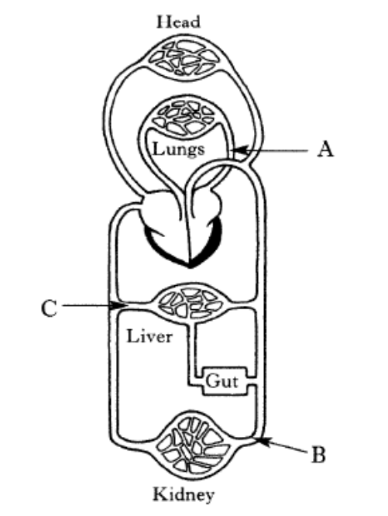
3
(a) Name the blood vessels labelled A, B and C in the diagram.

(b) The diagram below shows a cross section through an artery.
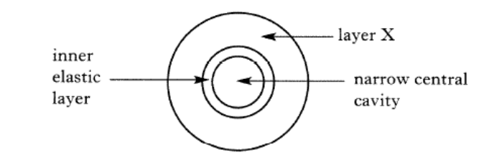
1
(i) Describe layer X.
1
(ii) Describe how the structure of layer X is related to its function.

(iii) The pulse beat can be felt in an artery.
1
What causes the pulse beat?

Q4. The sentences below describe how oxygen enters the bloodstream for use in respiration.
Pick one option from each statement to make the sentences correct.

Air entering the lungs passes down the bronchioles/trachea to the bronchi.
1

To collect oxygen, blood enters the lungs through the pulmonary artery/vein and returns to the left/right atrium of the heart.
1

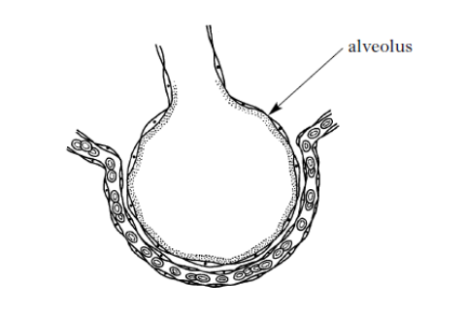
(b) The diagram below shows an alveolus in the lungs.

State two features of the alveolus that allow efficient gas exchange.
1
Feature 1_________________
1
Feature 2_________________

(c) (i) Oxygen diffuses into muscle cells for respiration. Name one other raw material needed for respiration that enters by diffusion.
1

(ii) Name a waste product of respiration that diffuses out of muscle cells.
1

END OF HOMEWORK 5

Sub-Unit 3C: Circulation and Gas Exchange
Homework 6: Section C questions on Circulation and Gas Exchange

Q1. Describe the structures of arteries, veins and capillaries. Give the function of each of these types of blood vessel.
5

Q2. The diagram below shows a section through the human heart.

X
Y

Describe the pathway of blood through the heart and associated structures starting with X and finishing with Y. There is no need to mention the valves.
5

END OF HOMEWORK 6

Sub-Unit 3D: Blood
Homework 7: Blood

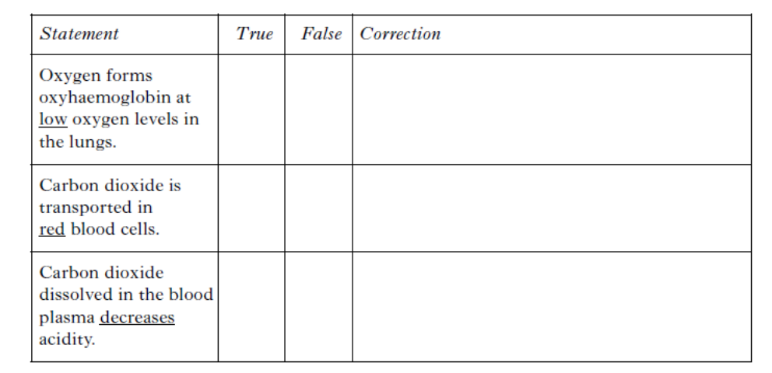
Q1. Decide if each of the following statements about the transport of gases by the bloodstream is True or False, and tick the appropriate box.
3

Q2. The bar graph below shows average blood pressure measurements in different blood vessels for a healthy individual.
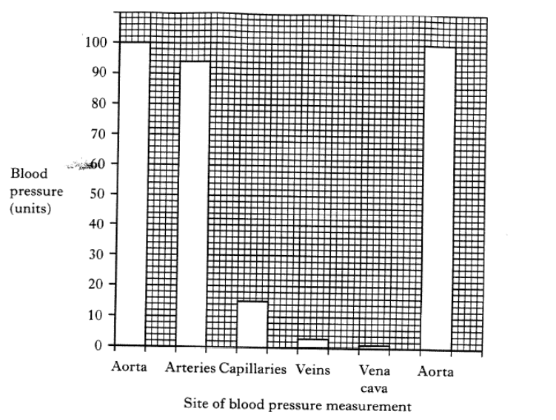
(a) Calculate the simple whole ratio of the blood pressure in the aorta to the blood pressure found in the capillaries.
1

(b) Calculate the percentage decrease in blood pressure when blood moves from a capillary to a vein.
1
1
(c) Explain what brings about the large increase in blood pressure between the vena cava and the aorta.

(d) The blood pressure in veins is very low.
1
Name the structures in veins that prevent the blood flowing backwards.

Q3. The oxygen concentration of the air decreases as height above sea level increases.
The table below shows the red blood cell count of a mountaineer taken at different heights above sea level.

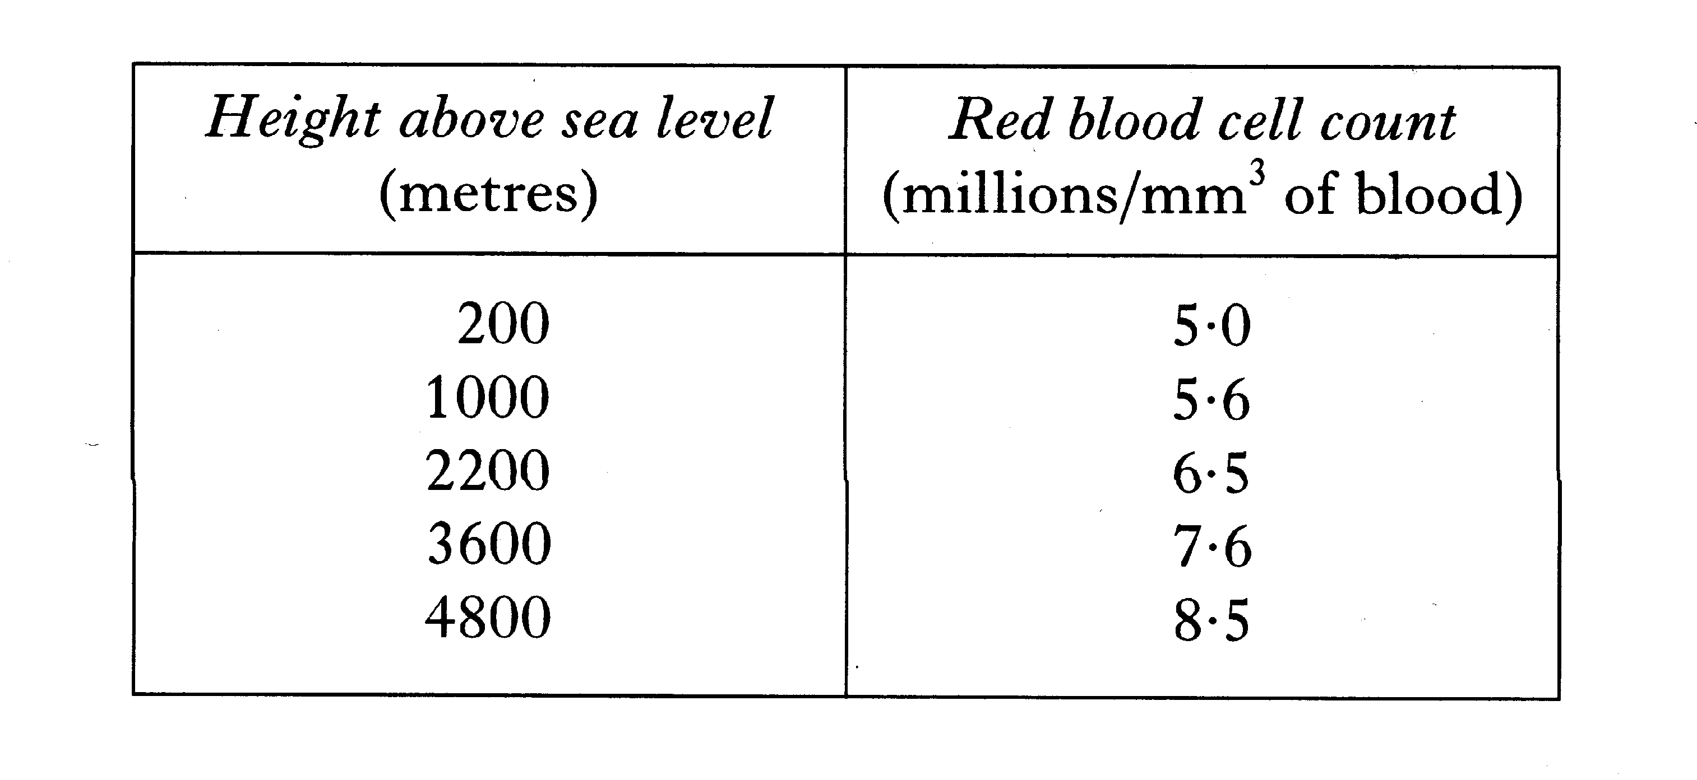

(a) On the grid, plot a line graph to show red blood cell count against height above sea level.
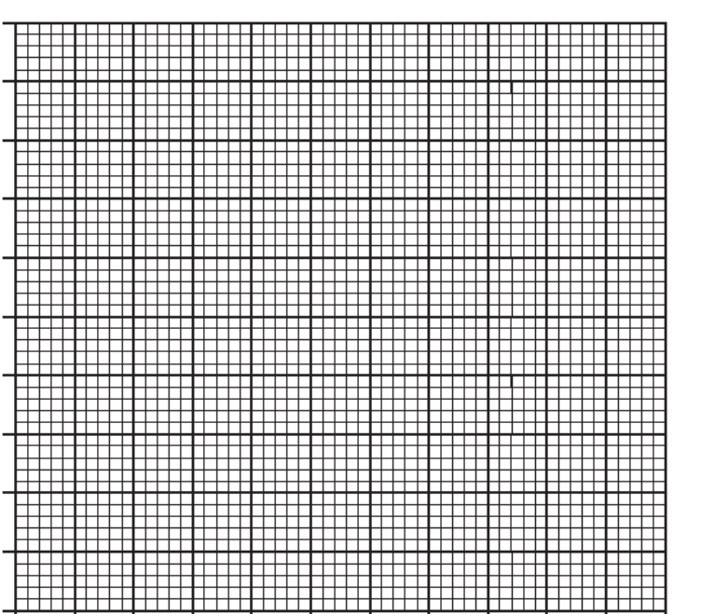
3

(b) (i) From the table, describe the relationship between the height above sea level and the red blood cell count.
1

(c) (ii) Explain the importance of this change in the red blood cell count.
1

END OF HOMEWORK 7

Sub-Unit 3D: Blood
Homework 8: Section C questions on Blood

Q1. Describe the role of antibodies and phagocytosis in defence. Name the cells involved in each of these defence mechanisms.
5

Q2. The diagram below shows human blood as seen through the microscope.
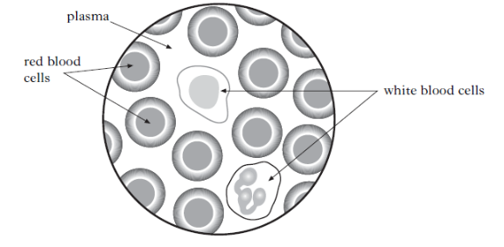
(a) Name the two parts of the blood involved in the transport of substances around the body.
(b) Describe how named substances are transported by each part of the blood.
5

Q3. Describe the role of macrophages and lymphocytes in defence.
5

END OF HOMEWORK 8

Sub-Unit 3D: Brain and Nervous System
Homework 9: Brain and Nervous System

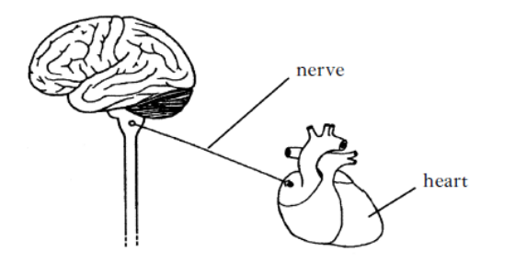
Q1. The diagram below shows parts of the central nervous system (CNS) and a nerve to the heart.

(i) Name the two parts, shown in the diagram, which make up the central nervous system (CNS).
1

(ii) Name the area, shown in the diagram, which controls heart rate.
1

(b) Reflex arcs contain relay fibres.
1
(i) Which structure sends impulses to the relay fibre?
1
(ii) What is the function of relay fibres in a reflex arc?

(c) Explain the function of a reflex response.
1

Q2. The following diagram shows the human brain.

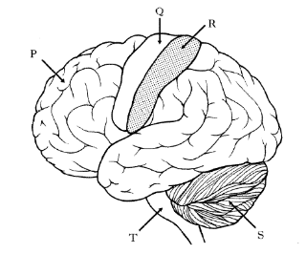

(a) Complete the table to identify areas of the brain and their functions.
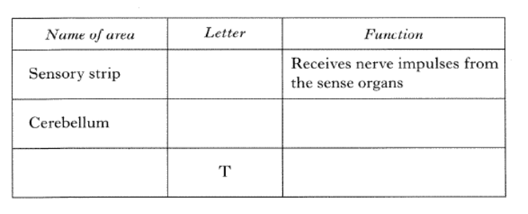
1
2
(b) The brain forms one part of the Central Nervous System (CNS).
Name the other part.

(c) Name the type of neurone which links the receptors in the sense organs to the CNS.
1

(d) Describe if each of the following statements about temperature regulation in the body is true or false and tick the appropriate box.
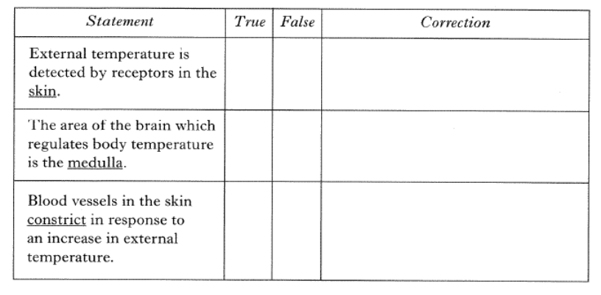
If the statement is false, write the correct word in the correction box.
3
Q3. The three types of neurone involved in the reflex arc for blinking
are shown in the diagram below.
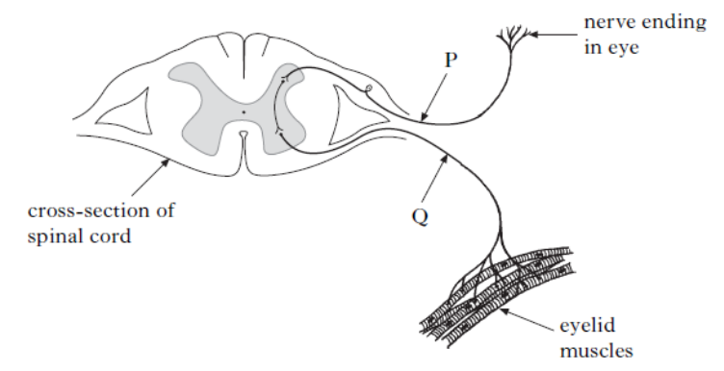

2
(a) Name neurones P and Q.
1
(b) Which labelled structure is the effector in this response?
1
(c) What is the function of a reflex arc?

END OF HOMEWORK 9
Sub-Unit 3D: Brain and Nervous System
Homework 10: Section C questions on Brain and Nervous System

Q1. The diagram below shows the nerve cells (neurones) involved in a reflex arc.
5
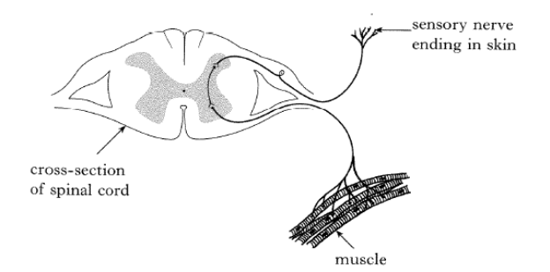
Describe the pathway of a nerve impulse through the reflex arc.
3
3

Q2. The diagram below shows a section through the brain.

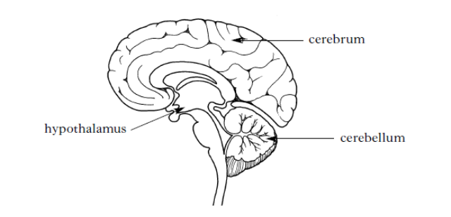
(a) Name the part of the brain that regulates body temperature.

(b) State its response to a decrease in body temperature by describing the changes which will occur in the skin, blood vessels and muscles.
5

END OF HOMEWORK 10

